**HANOI UNIVERSITY OF SCIENCE AND TECHNOLOGY**

**SCHOOL OF INFORMATION & COMMUNICATION TECHNOLOGY**

----- 🙡 🕮 🙣 -----



**GROUP 6 REPORT**

***Subject:* ITSS Software Development**

|  |  |
| --- | --- |
| Lecturer: | **Dr. Nguyen Thi Thu Trang** |
| Class: | 147822 |

|  |  |  |
| --- | --- | --- |
| Student Name | Student ID | Email |
| Nguyễn Đình Dũng | 20210230 | dung.nd210230@sis.hust.edu.vn |
| Trần Nam Dương | 20210263 | duong.tn210263@sis.hust.edu.vn |
| Trịnh Tiến Dũng | 20215187 | dung.tt215187@sis.hust.edu.vn |
| Vũ Minh Dũng | 20205179 | dung.vm205179@sis.hust.edu.vn |
| Nguyễn Mạnh Dũng | 20194745 |  |

**Ha Noi, 06/2024**

Contents

**1.** **Assign working** 4

**2.** **Use case specification** 5

**2.1.** **General use case diagram** 5

**2.2.** **Use case specification for “Search and sort product”** 6

**2.3.** **Use case specification for “View product detail”** 10

**2.4.** **Use case specification for “Manage Cart”** 12

**2.5.** **Use case specification for “Place Order”** 16

**2.6.** **Use case specification for “Place Rush Order”** 19

**2.8.** **Use case specification for “View list of products on home screen”** 24

**2.9.** **Use case specification for “Login”** 26

**2.10.** **Use case specification for “Block user”** 28

**2.11.** **Use case specification for “Create User”** 30

**2.12.** **Use case specification for “Update User”** 33

**2.13.** **Use case specification for “CRUD Product”** 36

**3.** **Use case analysis** 39

**3.1.** **Use case analysis for “Search/Sort product”** 39

**3.2.** **Use case analysis for “View product detail”** 41

**3.3.** **Use case analysis for “Manage Cart”** 42

**3.4.** **Use case analysis for “Place Order”** 45

**3.5.** **Use case analysis for "Place Rush Order”** 46

**3.6.** **Use case analysis for “Pay Order”** 47

**3.7.** **Use case analysis for "View list of products”** 48

**4.** **Interface Design** 49

**4.1.** **Splash screen** 49

**4.2.** **Home Screen** 50

**4.3.** **Product detail screen** 51

**4.4.** **Cart** 52

**4.5.** **Shipping information Screen** 53

**4.6.** **Invoice Screen** 55

**4.7.** **Payment Screen** 57

**4.8.** **Payment Result** 57

**4.9.** **Popup Screen** 58

**4.10.** **Login Screen** 58

**4.11.** **Product Manager** 59

**4.12.** **Media Manager** 60

**4.13.** **User Manager** 61

**5.** **Analysis Class Diagram** 62

**5.1.** **General Class Diagram** 62

**5.2.** **Class Diagram for package view** 63

**5.3.** **Class Diagram for Package Common** 64

**5.4.** **Class Diagram for Package Entity** 64

**5.5.** **Class Diagram for Package Subsystem** 65

**5.6.** **Class diagram for Package Utils** 65

**6.** **Data Modeling** 66

**6.1.** **Database Schema Diagram** 66

**6.2.** **Conceptual Data Model** 67

**6.3.** **Physical Data Model** 68

**7.** **Good Design** 70

**7.1.** **Cohesion** 70

**7.2.** **Coupling** 73

**7.3.** **SOLID** 75

**7.4.** **Design Pattern** 77

**7.4.1.** **Singleton** 77

**7.4.2.** **Strategy** 77

1. **Assign working**

|  |  |
| --- | --- |
| Nguyễn Đình Dũng | Design place order and place rush order functions, view order |
| Trần Nam Dương | Design payment functions, vnpay api ,  database |
| Nguyễn Mạnh Dũng | Design the product management functions of the product manager |
| Vũ Minh Dũng | Design the administrator's user management function, login |
| Trịnh Tiến Dũng | UC view list of products; view product detail; search, sort products; CRUD products in cart |

1. **Use case specification**
   1. **General use case diagram**

* 1. **Use case specification for “Search and sort product”**

|  |  |  |  |  |  |  |  |  |  |  |  |  |  |  |  |  |  |  |  |  |  |  |  |  |  |  |  |  |  |  |  |  |  |  |  |  |  |  |  |  |  |  |  |  |  |  |  |  |  |  |  |  |  |  |  |  |  |  |  |  |  |  |  |
| --- | --- | --- | --- | --- | --- | --- | --- | --- | --- | --- | --- | --- | --- | --- | --- | --- | --- | --- | --- | --- | --- | --- | --- | --- | --- | --- | --- | --- | --- | --- | --- | --- | --- | --- | --- | --- | --- | --- | --- | --- | --- | --- | --- | --- | --- | --- | --- | --- | --- | --- | --- | --- | --- | --- | --- | --- | --- | --- | --- | --- | --- | --- | --- |
| **Use Case “Search, Sort products”**   1. **Use case code**   UC002   1. **Brief Description**   This use case describes the interaction between customer and AIMS when customer wish(es) to search or sort products on the home screen   1. **Actors**   Customer   1. **Preconditions**   Customer successfully view products on the home screen.   1. **Basic Flow of Events**    1. **Search product** 2. The customer searches for products by title or category. (see Table A) 3. AIMS looks up in database products satisfy the customer request. 4. AIMS displays result to home screen. (see Table B)    1. **Sort products** 5. The customer requests ascending sort of products. 6. AIMS sorts products prices in ascending order. 7. AIMS displays sorted products on the home screen. (see Table B) 8. **Alternative flows**   **Table 1-Alternative flows of events for UC Search products**   |  |  |  |  |  | | --- | --- | --- | --- | --- | | **No** | **Location** | **Condition** | **Action** | **Resume location** | | 1 | At Step 3 | If there is no product match search request | * System displays no product found | End use case |   **Table 2-Alternative flows of events for UC Sort products**   |  |  |  |  |  | | --- | --- | --- | --- | --- | | **No** | **Location** | **Condition** | **Action** | **Resume location** | | 1 | At Step 1 | If customer requests descending sort. | * AIMS sorts products prices in descending order | Resumes at Step 3 |  1. **Input data**   **Table A-Input data of UC Search products**   |  |  |  |  |  |  | | --- | --- | --- | --- | --- | --- | | **No** | **Data fields** | **Description** | **Mandatory** | **Valid condition** | **Example** | | 1 | Product title | Title of searched product | No | Text | Harry Potter | | 2 | Product category | Category of searched product | No | Choose from list | Book |  1. **Output data**   **Table B-Output data of UC Searched products**   |  |  |  |  |  | | --- | --- | --- | --- | --- | | **No** | **Data fields** | **Description** | **Display format** | **Example** | | 1 | Image | Image of product’s cover | Image |  | | 2 | Title | Title of product | Text | Harry Potter | | 3 | Price | Price of product | - Comma for thousands  Separator  - Positive integer  - Right alignment | 100.000 vnd | | 4 | Avail | Available quantity of product | - Positive integer  - Right alignment | 10 |  1. **Postconditions** 2. **Activity Diagrams**    1. **Search products**  * 1. **Sort products** |

* 1. **Use case specification for “View product detail”**

|  |  |  |  |  |  |  |  |  |  |  |  |  |  |  |  |  |  |  |  |  |  |  |  |  |  |  |  |  |  |  |  |  |  |  |  |  |  |  |  |  |  |  |  |  |  |  |  |  |  |  |  |  |  |  |  |  |  |  |  |  |  |  |  |  |  |  |  |  |  |  |  |  |  |  |  |  |  |  |  |  |  |  |  |  |  |  |  |  |  |  |  |  |  |  |  |  |  |  |  |  |  |  |  |  |  |  |  |  |  |  |  |  |  |  |  |
| --- | --- | --- | --- | --- | --- | --- | --- | --- | --- | --- | --- | --- | --- | --- | --- | --- | --- | --- | --- | --- | --- | --- | --- | --- | --- | --- | --- | --- | --- | --- | --- | --- | --- | --- | --- | --- | --- | --- | --- | --- | --- | --- | --- | --- | --- | --- | --- | --- | --- | --- | --- | --- | --- | --- | --- | --- | --- | --- | --- | --- | --- | --- | --- | --- | --- | --- | --- | --- | --- | --- | --- | --- | --- | --- | --- | --- | --- | --- | --- | --- | --- | --- | --- | --- | --- | --- | --- | --- | --- | --- | --- | --- | --- | --- | --- | --- | --- | --- | --- | --- | --- | --- | --- | --- | --- | --- | --- | --- | --- | --- | --- | --- | --- | --- | --- |
| **Use Case “View product detail”**   1. **Use case code**   UC003   1. **Brief Description**   This use case describes the interaction between customer and AIMS when customer wish(es) to view product detail   1. **Actors**   Customer   1. **Preconditions**   Customer successfully views list of products on the home screen.   1. **Basic Flow of Events** 2. The customer requests to view detail information of a product 3. AIMS checks for category of the product 4. AIMS shows detail information of the product (if Book see Table A, if DVD see Table B, if CD see Table C) 5. **Alternative flows** 6. **Input data** 7. **Output data**   **Table A-Output data of Book’s detail information**   |  |  |  |  |  | | --- | --- | --- | --- | --- | | **No** | **Data fields** | **Description** | **Display format** | **Example** | | 1 | Image | Image of book’s cover | Image |  | | 2 | Title | Title of book | Text | Harry Potter | | 3 | Author | Author of book | Text | J.K.Rowling | | 4 | Publisher | Publisher of book | Text | Bloomsbury | | 5 | Publish Date | Publish Date of book | dd/mm/yyyy | 26/06/1997 | | 6 | Language | Language used in book | Text | English | | 7 | Category | Category of book | Text | Fantasy | | 8 | Numbers of Pages | Numbers of Pages of book | Positive Integer | 700 |   **Table B-Output data of DVD’s detail information**   |  |  |  |  |  | | --- | --- | --- | --- | --- | | **No** | **Data fields** | **Description** | **Display format** | **Example** | | 1 | Image | Image of DVD’s cover | Image |  | | 2 | Title | Title of DVD | Text | Harry Potter | | 3 | Director | Director of DVD | Text | Chris Columbus | | 4 | Studio | Name of DVD production studio | Text | Warner Bros. Pictures | | 5 | Released Date | Released Date of DVD | dd/mm/yyyy | 11/05/2002 | | 6 | Type | Type of DVD | Text | Fantasy |   **Table C-Output data of CD’s detail information**   |  |  |  |  |  | | --- | --- | --- | --- | --- | | **No** | **Data fields** | **Description** | **Display format** | **Example** | | 1 | Image | Image of CD’s cover | Image |  | | 2 | Title | Title of CD | Text | 1989 | | 3 | Artist | Artist of CD | Text | Taylor Swift | | 4 | Record Label | Record Label of CD | Text | Big Machine Records | | 5 | Record Date | Record Date of CD | dd/mm/yyyy | 27/10/2014 | | 6 | Music Type | Music Type of CD | Text | Pop |  1. **Postconditions** 2. **Activity Diagrams** |

* 1. **Use case specification for “Manage Cart”**

|  |  |  |  |  |  |  |  |  |  |  |  |  |  |  |  |  |  |  |  |  |  |  |  |  |  |  |  |  |  |  |  |  |  |  |  |  |  |  |  |  |  |  |  |  |  |  |  |  |  |  |  |  |  |  |  |  |  |
| --- | --- | --- | --- | --- | --- | --- | --- | --- | --- | --- | --- | --- | --- | --- | --- | --- | --- | --- | --- | --- | --- | --- | --- | --- | --- | --- | --- | --- | --- | --- | --- | --- | --- | --- | --- | --- | --- | --- | --- | --- | --- | --- | --- | --- | --- | --- | --- | --- | --- | --- | --- | --- | --- | --- | --- | --- | --- |
| **Use Case “CRUD product in Cart”**   1. **Use case code**   UC004   1. **Brief Description**   This use case describes the interaction between customer and AIMS when customer wish(es) to CRUD product in cart   1. **Actors**   Customer   1. **Preconditions**   Customer successfully views list of products on the home screen.   1. **Basic Flow of Events**    1. **Add product to cart**   1. The customer selects a product and the quantity they want to purchase.  2. The customer requests to add the product to cart.  3. AIMS displays a notification that the product has been successfully added.   * 1. **View product in cart**   1. The customer requests to view the shopping cart.  2. AIMS displays a list of products in the shopping cart.  3. AIMS displays the total amount for the products. (see Table A)   * 1. **Delete product in cart**  1. The customer views products in cart 2. The customer delete products from cart   3. AIMS displays list of products after delete.  4. AIMS updates and displays the total amount for the products. (see Table A)   * 1. **Update product in cart**   1. The customer views products in cart.  2. The customer updates the products’ quantity.  3. AIMS updates and displays the total amount for the products. (see Table A)   1. **Alternative flows**   **Table 1-Alternative flows of events for Add product to cart**   |  |  |  |  |  | | --- | --- | --- | --- | --- | | **No** | **Location** | **Condition** | **Action** | **Resume location** | | 1 | At Step 2 | The quantity added to the cart exceeds the quantity in stock | AIMS displays error message: The number of products in stock is not enough | Resumes at Step 1 |   **Table 2-Alternative flows of events for Update product in cart**   |  |  |  |  |  | | --- | --- | --- | --- | --- | | **No** | **Location** | **Condition** | **Action** | **Resume location** | | 1 | At Step 2 | The updated quantity exceeds the quantity in stock | AIMS displays error message: The number of products in stock is not enough | Resumes at Step 1 |  1. **Input data** 2. **Output data**   **Table A-Output data of View products in cart**   |  |  |  |  |  | | --- | --- | --- | --- | --- | | **No** | **Data fields** | **Description** | **Display format** | **Example** | |  | Image | Image of product’s cover | Image |  | |  | Title | Title of product | Text | Harry Potter | |  | Quantity | Quantity of product | - Positive integer  - Right alignment | 10 | |  | Price | Price of product | - Comma for thousands  Separator  - Positive integer  - Right alignment | 100.000 vnd | |  | Subtotal | Total price of products in the cart before VAT | 100.000 vnd | |  | VAT | Value Added Tax | 10.000 vnd | |  | Amount | Total price of products in the cart after VAT | 1. d |  1. **Postconditions** 2. **Activity Diagrams**    1. **Add product to cart**  * 1. **View product in cart**  * 1. **Delete product in cart**  * 1. **Update product in cart** |

* 1. **Use case specification for “Place Order”**

|  |  |  |  |  |  |  |  |  |  |  |  |  |  |  |  |  |  |  |  |  |  |  |  |  |  |  |  |  |  |  |  |  |  |  |  |  |  |  |  |  |  |  |  |  |  |  |  |  |  |  |  |  |  |  |  |  |  |  |  |  |  |  |  |  |  |  |  |  |  |  |  |  |  |  |  |  |  |  |  |  |  |  |  |  |  |  |  |  |  |  |
| --- | --- | --- | --- | --- | --- | --- | --- | --- | --- | --- | --- | --- | --- | --- | --- | --- | --- | --- | --- | --- | --- | --- | --- | --- | --- | --- | --- | --- | --- | --- | --- | --- | --- | --- | --- | --- | --- | --- | --- | --- | --- | --- | --- | --- | --- | --- | --- | --- | --- | --- | --- | --- | --- | --- | --- | --- | --- | --- | --- | --- | --- | --- | --- | --- | --- | --- | --- | --- | --- | --- | --- | --- | --- | --- | --- | --- | --- | --- | --- | --- | --- | --- | --- | --- | --- | --- | --- | --- | --- | --- |
| **Use Case “Place Order”**   1. **Use case code**   UC005   1. **Brief Description**   This use case describes the interaction between customer and AIMS when customer wish(es) to place order   1. **Actors**   Customer   1. **Preconditions**   None   1. **Basic Flow of Events** 2. Customers click to view cart. 3. The system calculates the total product price. 4. The system checks whether the products in the cart are still in stock. 5. The system will display a list of items the customer wants to order (product name, quantity, and price). 6. Customer clicks on the “Place Order” button. 7. The system checks whether the products in the cart are still in stock. 8. The system displays a delivery information form, asking the customer to update shipment details. 9. Customers fill in the necessary information and do not select "fast delivery". 10. Click “Update”. 11. The system checks input information. 12. Delivery fee calculation system. 13. The system will display temporary order information. 14. Call Use case “Payment”. 15. System empties cart. 16. **Alternative flows**  |  |  |  |  |  | | --- | --- | --- | --- | --- | | **No** | **Location** | **Condition** | **Action** | **Resume location** | | 1 | At Step 3 | If system check in insufficient warehouse  products. | The system will notify customers the product is not enough in stock and requires the customer to update the cart with missing products. | Resumes at Step 4. | | 2 | At step 8 | If the customer misses the required information fields blank or write in the wrong format. | The system will ask the customer to enter complete information. | Resumes at Step 8. | | 3 | At step 8 | If the customer selects “Place Rush Order” | Insert into usecase “Place Rush Order” | Continue usecase “Place Rush Order” | | 4 | At step 1 | If there are no products in the cart. | The system will notify you that there are no products in the cart product | Resumes at Step 1. |  1. **Input data**   **Table A-Input data of “delivery information form”**   |  |  |  |  |  |  | | --- | --- | --- | --- | --- | --- | | **No** | **Data fields** | **Description** | **Mandatory** | **Valid condition** | **Example** | | 1 | Address | Address of customer | Yes | Text | Số 1, Đường Tạ Quang Bửu, quận Hai Bà Trưng. | | 2 | Name of customer |  | Yes | Maximum 30 characters | Nguyen Van A | | 3 | Phone number |  | Yes | From 9 – 11 numbers (first number need be 0) | 0998716388 | | 4 | Province |  | Yes | Choose from list | Ha Noi |  1. **Output data**   **Table B-Output data of “Temporary order information sheet”**   |  |  |  |  |  | | --- | --- | --- | --- | --- | | **No** | **Data fields** | **Description** | **Display format** | **Example** | | 1 | Title | Name of Product | Text | Harry Potter Book | | 2 | Price | Price of product | - Comma for thousands  Separator  - Positive integer  - Right alignment | 100.000 vnd | | 3 | Quantity | Quantity of product | - Positive integer | 10 | | 4 | Sum price of product | Sum price of each product | - Comma for thousands  Separator  - Positive integer  - Right alignment | 300,00 vnđ | | 5 | Total amount payable before calculation shipping fee | Total price of all products before calculation shipping fee | - Comma for thousands  Separator  - Positive integer  - Right alignment | 20,000 vnđ | | 6 | Total amount money | Total amout money of all products after calculation shipping fee | - Comma for thousands  Separator  - Positive integer  - Right alignment | 320,000 vnđ |  1. **Postconditions** 2. **Activity Diagrams** |

* 1. **Use case specification for “Place Rush Order”**

|  |  |  |  |  |  |  |  |  |  |  |  |  |  |  |  |  |  |  |  |  |  |  |  |  |  |  |  |  |  |  |  |  |  |  |  |  |  |  |  |  |  |  |  |  |  |  |  |  |  |  |  |  |  |  |  |  |  |  |  |  |  |  |  |  |  |  |  |  |  |  |  |  |  |  |  |  |  |  |  |  |  |  |  |  |  |  |  |  |  |  |  |  |  |  |  |  |  |  |  |  |  |
| --- | --- | --- | --- | --- | --- | --- | --- | --- | --- | --- | --- | --- | --- | --- | --- | --- | --- | --- | --- | --- | --- | --- | --- | --- | --- | --- | --- | --- | --- | --- | --- | --- | --- | --- | --- | --- | --- | --- | --- | --- | --- | --- | --- | --- | --- | --- | --- | --- | --- | --- | --- | --- | --- | --- | --- | --- | --- | --- | --- | --- | --- | --- | --- | --- | --- | --- | --- | --- | --- | --- | --- | --- | --- | --- | --- | --- | --- | --- | --- | --- | --- | --- | --- | --- | --- | --- | --- | --- | --- | --- | --- | --- | --- | --- | --- | --- | --- | --- | --- | --- | --- |
| **Use Case “Place Rush Order”**   1. **Use case code**   UC006   1. **Brief Description**   This use case describes the interaction between customer and AIMS when customer wish(es) to place order   1. **Actors**   Customer   1. **Preconditions**   None   1. **Basic Flow of Events** 2. The system displays the delivery address information fieldsThe system calculates the total product price. 3. User enters information fields. 4. User confirms 5. The system checks whether the fields are valid. 6. The system switches to the delivery method selection screen. 7. The user selects the fast delivery method 8. User confirms. 9. The system calculates delivery fees and displays the invoice screen. 10. User confirms. 11. The system switches to payment. 12. **Alternative flows**  |  |  |  |  |  | | --- | --- | --- | --- | --- | | **No** | **Location** | **Condition** | **Action** | **Resume location** | | 1 | At step 4 | If the customer misses the required information fields blank or write in the wrong format | The system will ask the customer to enter complete information. | Resumes at Step 2. | | 2 | At step 6 | The address checking system does not support fast shipping | Fast delivery is not allowed | Resumes at Step 6. | | 3 | At step 6 | There are no product which is fast dilivery sopported | Fast delivery is not allowed products in the cart product | Resumes at Step 6. |   **Table A-Input data of “delivery information form”**   |  |  |  |  |  |  | | --- | --- | --- | --- | --- | --- | | **No** | **Data fields** | **Description** | **Mandatory** | **Valid condition** | **Example** | |  | Address | Address of customer | Yes | Text | Số 1, Đường Tạ Quang Bửu, quận Hai Bà Trưng. | |  | Name of customer |  | Yes | Maximum 30 characters | Nguyen Van A | |  | Phone number |  | Yes | From 9 – 11 numbers (first number need be 0) | 0998716388 | |  | Province |  | Yes | Choose from list | Ha Noi | |  | Shipping  Instructions |  | No | Maximum 50 characters | Khong |  1. **Output data**   **Table B-Output data of “Temporary rush order information sheet”**   |  |  |  |  |  | | --- | --- | --- | --- | --- | | **No** | **Data fields** | **Description** | **Display format** | **Example** | | 1 | Title | Name of Product | Text | Harry Potter Book | | 2 | Price | Price of product | - Comma for thousands  Separator  - Positive integer  - Right alignment | 100.000 vnd | | 3 | Quanity | Quantity of product | - Positive integer | 10 | | 4 | Type of delivery |  | Normal or Fast | Fast | | 5 | Sum price of product | Sum price of each product | - Comma for thousands  Separator  - Positive integer  - Right alignment | 300,00 vnđ | | 6 | Total amount payable before calculation shipping fee | Total price of all products before calculation shipping fee | - Comma for thousands  Separator  - Positive integer  - Right alignment | 20,000 vnđ | | 7 | Total amount fee of rush delivery | 10,000 vnđ for each rush delivery product | - Comma for thousands  Separator  - Positive integer  - Right alignment | 50,000 vnđ | | 8 | Total amount money | Total amout money of all products after calculation shipping fee | - Comma for thousands  Separator  - Positive integer  - Right alignment | 370,000 vnđ |  1. **Postconditions** 2. **Activity Diagrams** |

* 1. **Use case specification for “Pay order”**

|  |  |  |  |  |  |  |  |  |  |  |
| --- | --- | --- | --- | --- | --- | --- | --- | --- | --- | --- |
| 1. **Usecase code:**   UC007   1. **Brief Description:**   This usecase describes the interaction between the customer and the AIMS system when the user pay for the order.   1. **Actors:**   Customer, VNPay subsystem.   1. **Preconditions:** UC Place Order after user confirm shipping method. 2. **Flow of action:** 3. The customer confirm the order. 4. AIMS redirect the customer to VNPay payment page. 5. The customer finish payment for the order through VNPay 6. AIMS display Payment Successful page. 7. **Alternate flows for Searching**  |  |  |  |  |  | | --- | --- | --- | --- | --- | | **No** | **Location** | **Condition** | **Action** | **Resume location** | | 1 | At Step 3 | User cancel the payment | AIMS display Payment Failed Page | End usecase |  1. **Input data** 2. **Output data** 3. **Postconditions:** None 4. **Activity diagram** |

* 1. **Use case specification for “View list of products on home screen”**

|  |  |  |  |  |  |  |  |  |  |  |  |  |  |  |  |  |  |  |  |  |  |  |  |  |  |
| --- | --- | --- | --- | --- | --- | --- | --- | --- | --- | --- | --- | --- | --- | --- | --- | --- | --- | --- | --- | --- | --- | --- | --- | --- | --- |
| **Use Case “View list of products”**   1. **Use case code**   UC008   1. **Brief Description**   This use case describes the interaction between customer and AIMS when customer wish(es) to view product detail   1. **Actors**   Customer  **4.** **Preconditions**  **5.** **Basic Flow of Events**  1. The customer access AIMS  2. AIMS initialize home screen  3. AIMS get all media information from database  4. AIMS displays list of 20 products on each page  **6.** **Alternative flows**  **7.** **Input data**  **8.** **Output data**  **Table A-Output data of Book’s detail information**   |  |  |  |  |  | | --- | --- | --- | --- | --- | | **No** | **Data fields** | **Description** | **Display format** | **Example** | | 1. | Image | Image of product’s cover | Image |  | | 2. | Title | Title of product | Text | Harry Potter | | 3. | Price | Price of product | - Comma for thousands  Separator  - Positive integer  - Right alignment | 100.000 vnd | | 4. | Avail | Available quantity of product | - Positive integer  - Right alignment | 10 |     **9.** **Postconditions**  **10.** **Activity Diagrams** |

* 1. **Use case specification for “Login”**

|  |  |  |  |  |  |  |  |  |  |  |  |  |  |  |  |  |  |  |  |  |  |  |  |  |  |  |  |  |  |  |
| --- | --- | --- | --- | --- | --- | --- | --- | --- | --- | --- | --- | --- | --- | --- | --- | --- | --- | --- | --- | --- | --- | --- | --- | --- | --- | --- | --- | --- | --- | --- |
| **Use case “Login”**   1. **Use case code**   UC009   1. **Brief description**   The use case describes the interaction between user and system when the user wishes to login.   1. **Actors**   User, system   1. **Preconditions**   None   1. **Basic flows of event**   **Step 1:** The user clicks the “Login” button.  **Step 2:** The application displays the login form  **Step 3:** The user fills in the login form **(Table A)** and clicks to “login” button to send information to the application  **Step 4:** The system checks username and password of the user  **Step 5:** The system checks whether that user is block  **Step 6:** The system checks the roles of the user  **Step 7:** The system displays the manager screen with tabs based on the user's role.   1. **Alternative flows**  |  |  |  |  |  | | --- | --- | --- | --- | --- | | No | Location | Condition | Action | Resumes location | | 1 | At step 4 | If the user is not existed or the user’s information is wrong | The system displays the error “Wrong username or password” | at step 3 | | 2 | At step 5 | If the user is blocked | The system displays the error “This user is blocked” | at step 3 |  1. **Input data**  |  |  |  |  |  | | --- | --- | --- | --- | --- | | No | Data fields | Description | Display format | Example | | 1. | username | username of the user | text | admin | | 2. | password |  | password | 123@123 |  1. **Output data**   None   1. **Post condition**   **None**   1. **Activity diagram**    |

* 1. **Use case specification for “Block user”**

|  |  |  |  |  |  |  |  |  |  |  |
| --- | --- | --- | --- | --- | --- | --- | --- | --- | --- | --- |
| **Use case “Block User”**   1. **Use case code**   UC010   1. **Brief description**   The use case describes the interaction between admin and system when the admin wishes to block an user.   1. **Actors**   admin, system   1. **Preconditions**   None   1. **Basic flows of event**   **Step 1:** In the manage User screen, the system displays a table that contains user information.  **Step 2:** The admin chooses the user that he/she wants to block  **Step 3:** The admin clicks the “block user” button.  **Step 4:** The system displays the confirmation box: “Do you want to block this user?”  **Step 5:** The admin clicks to “yes” to confirm blocking.  **Step 6:** The system sends an update query to the database with the id of the chosen user to update the ban value to true.   1. **Alternative flows**  |  |  |  |  |  | | --- | --- | --- | --- | --- | | No | Location | Condition | Action | Resume Location | | 1. | At step 5 | If the admin click to “No” button | Nothing happens | end use case |  1. **Input data**   None   1. **Output data**   None   1. **Post Conditional**   None  **10. Activity Diagram**   |

* 1. **Use case specification for “Create User”**

|  |  |  |  |  |  |  |  |  |  |  |  |  |  |  |  |  |  |  |  |  |  |  |  |  |  |  |  |  |  |  |  |  |  |  |  |  |  |  |  |  |  |  |  |  |  |
| --- | --- | --- | --- | --- | --- | --- | --- | --- | --- | --- | --- | --- | --- | --- | --- | --- | --- | --- | --- | --- | --- | --- | --- | --- | --- | --- | --- | --- | --- | --- | --- | --- | --- | --- | --- | --- | --- | --- | --- | --- | --- | --- | --- | --- | --- |
| **Use Case “Create User”**   1. **Use case code**   UC011   1. **Brief description**   The usecase describes the interaction between admin and system when the admin wishes to create new user   1. **Actors**   Admin, System   1. **Precondition**   The user has role admin   1. **Basic flows of event**   **1. Step 1:** The admin clicks the “create User” button on the manage User screen.  **2. Step 2:** The system displays the “create user” form **(Table A)**.  **3. Step 3:** The admin fills in the form and clicks the “save new user” button.  **4. Step 4:** The system checks the validation of filled in information.  **5. Step 5:** The system checks the existing username in the database.  **6. Step 6:** The system creates a new user based on the provided information and with default password is 123123.  **7. Step 7:** The system sends a create query to database to create a new user in database with provided information  **8. Step 8:** The system fills a new user in the “user” Table View.   1. **Alternative flows**  |  |  |  |  |  | | --- | --- | --- | --- | --- | | **No.** | **Location** | **Condition** | **Action** | **Resume Location** | | 1. **á** | At step 4 | If the filled information is invalid | The system displays error to the admin | Resume at step 3 | |  | At step 5 | if the provided username is existed | The system displays error to the admin | Resume at step 3 |  1. **Input Data**  |  |  |  |  |  | | --- | --- | --- | --- | --- | | **No** | **Data field** | **description** | **display format** | **example** | | 1. | username | username of a new user | text | vusnow36 | | 2. | email | email of new user | text@gmail.com | abcde@gmail.com | | 3. | phone | phone number | 10 digits of number starting 0 | 0123456789 | | 4. | address | address of new user | text | Ha Noi | | 5. | role | role of new user | multiple choices box | admin, product manager |      1. **Output Data**   None   1. **Post condition**   None   1. **Activity Diagram**    |

* 1. **Use case specification for “Update User”**

|  |  |  |  |  |  |  |  |  |  |  |  |  |  |  |  |  |  |  |  |  |  |  |  |  |  |  |  |  |  |  |  |  |  |  |  |  |  |  |  |  |
| --- | --- | --- | --- | --- | --- | --- | --- | --- | --- | --- | --- | --- | --- | --- | --- | --- | --- | --- | --- | --- | --- | --- | --- | --- | --- | --- | --- | --- | --- | --- | --- | --- | --- | --- | --- | --- | --- | --- | --- | --- |
| **Use case “Update User”**   1. **Use case code**   UC012   1. **Brief description**   This use case describes the interaction between admin and system when the admin wants to update information of another user   1. **Actors**   Admin, System   1. **Pre-condition**   The user has role admin   1. **Basic flows of event**   **1. Step 1:** At “manage user” screen, the system displays the table that contains a list of users and their information  **2. Step 2:** The admin chooses 1 user in that table and click “Update User” button  **3. Step 3:** The system takes information of the chosen user  **4. Step 4:** The system displays the information form together with the information of the chosen user.  **5. Step 5:** The admin makes a change in the above information and click to “save update” button  **6. Step 6:** The system checks the validation of the submitted information.  **7. Step 7:** The system operates an update query in the database to change the information of the chosen user.   1. **Alternative flows**  |  |  |  |  |  | | --- | --- | --- | --- | --- | | **No.** | **Location** | **Condition** | **Action** | **Resume location** | |  | At step 6 | If the provided information is invalid format | The system displays error to admin | resumes at step 4 |      1. **Input data**  |  |  |  |  |  | | --- | --- | --- | --- | --- | | **No.** | **Data field** | **description** | **format** | **example** | |  | username | username of user | text | vusnow36 | | 2. | email |  | text@gmail.com | abcd@gmail.com | | 3. | phone | phone number | 10 digits starting with 0 | 0123456789 | | 4. | address | address | text | Ha Noi | | 5. | role | role of users | multiple choices box | admin, product manager |      1. **Output data**   None   1. **Post condition**   None   1. **Activity diagram**    |

* 1. **Use case specification for “CRUD Product”**

|  |  |  |  |  |  |  |  |  |  |  |  |  |  |  |  |  |  |  |  |  |  |  |  |  |  |  |  |  |  |  |  |  |  |  |  |  |  |  |  |  |  |  |  |  |  |  |  |  |  |  |  |  |  |  |  |  |  |  |  |  |  |  |  |  |  |  |  |  |  |  |  |  |  |  |  |  |  |  |  |  |  |  |  |  |  |  |  |  |  |  |  |  |  |  |  |  |  |  |  |  |  |  |  |  |  |  |  |  |  |  |  |  |  |  |  |  |  |  |  |  |  |  |  |  |  |  |  |  |  |  |  |  |  |  |  |  |  |  |  |  |  |  |  |  |  |  |  |  |  |  |  |  |  |  |  |  |  |  |  |  |  |  |  |  |  |  |  |  |  |  |  |  |  |  |  |  |  |  |  |  |  |  |  |  |  |  |  |  |  |  |
| --- | --- | --- | --- | --- | --- | --- | --- | --- | --- | --- | --- | --- | --- | --- | --- | --- | --- | --- | --- | --- | --- | --- | --- | --- | --- | --- | --- | --- | --- | --- | --- | --- | --- | --- | --- | --- | --- | --- | --- | --- | --- | --- | --- | --- | --- | --- | --- | --- | --- | --- | --- | --- | --- | --- | --- | --- | --- | --- | --- | --- | --- | --- | --- | --- | --- | --- | --- | --- | --- | --- | --- | --- | --- | --- | --- | --- | --- | --- | --- | --- | --- | --- | --- | --- | --- | --- | --- | --- | --- | --- | --- | --- | --- | --- | --- | --- | --- | --- | --- | --- | --- | --- | --- | --- | --- | --- | --- | --- | --- | --- | --- | --- | --- | --- | --- | --- | --- | --- | --- | --- | --- | --- | --- | --- | --- | --- | --- | --- | --- | --- | --- | --- | --- | --- | --- | --- | --- | --- | --- | --- | --- | --- | --- | --- | --- | --- | --- | --- | --- | --- | --- | --- | --- | --- | --- | --- | --- | --- | --- | --- | --- | --- | --- | --- | --- | --- | --- | --- | --- | --- | --- | --- | --- | --- | --- | --- | --- | --- | --- | --- | --- | --- | --- | --- | --- | --- | --- | --- | --- | --- |
| **Use case “Create Product”**   1. **Use case code**   UC013   1. **Brief description**   The usecase describes the interaction between product manager and the system when the product manager wishes to add a new product to their shop   1. **Actors**   product manager, system   1. **Pre-condition**   The user has role “product manager”   1. **Basic flows of event**    1. **Step 1:** In the product manager screen, the product manager chooses the type of media he/she wishes to add by choose exactly tab on tab pane    2. **Step 2:** In each tab, the system displays the specific content of these media based on their type.    3. **Step 3:** The product manager clicks “create” button to add new media    4. **Step 4:** The system displays the information form of new media    5. **Step 5:** The product manager fills in that form and clicks “create” one more time    6. **Step 6:** The system checks the validation of submitted information    7. **Step 7:** The system adds that new product to the database    8. **Step 8:** The system displays the list of media containing created media 2. **Alternative flows**  |  |  |  |  |  | | --- | --- | --- | --- | --- | | **No** | **Location** | **Condition** | **Action** | **Resume location** | | 1 | At step 6 | if the submitted information is invalid | The system displays error | resumes at step 4 |  1. **Input data**   **Table A – input data for Book**   |  |  |  |  |  | | --- | --- | --- | --- | --- | | **No** | **Data field** | **Description** | **Format** | **Example** | | 1 | id | the id of book | digit | 10 | | 2 | title | the title of book | text | book123 | | 3 | category | the category of book | text | adventure | | 4 | cover type |  | select from list | hardcover | | 5 | publisher |  | text | Kim Dong | | 6 | publish date |  | yyyy-MM-dd | 1997-04-02 | | 7 | num of pages |  | integer | 100 | | 8 | language |  | text | English | | 9 | value |  | integer | 40 | | 10 | price |  | integer | 100 | | 11 | quantity |  | integer | 20 |   **Table B – input data for CD**   |  |  |  |  |  | | --- | --- | --- | --- | --- | | **No** | **Data field** | **Description** | **Format** | **Example** | | 1 | id | the id of book | digit | 10 | | 2 | title | the title of book | text | cd2 | | 3 | category | the category of book | text | trap | | 4 | artist |  | text | unknown | | 5 | record label |  | text | unknown | | 6 | release date |  | yyyy-MM-dd | 1997-04-02 | | 7 | num of pages |  | integer | 100 | | 8 | music type |  | text | trap | | 9 | value |  | integer | 40 | | 10 | price |  | integer | 100 | | 11 | quantity |  | integer | 20 |   **Table C – input data for DVD**   |  |  |  |  |  | | --- | --- | --- | --- | --- | | **No** | **Data field** | **Description** | **Format** | **Example** | | 1 | id | the id of book | digit | 10 | | 2 | title | the title of book | text | dvd100 | | 3 | disc type |  | text | dvd | | 4 | director |  | text | Mr horror | | 5 | run time |  | integer | 10 | | 6 | studio |  | text | group 6 | | 7 | subtitile |  | text | English | | 8 | release date |  | date | 1970-12-01 | | 9 | value |  | integer | 40 | | 10 | price |  | integer | 100 | | 11 | quantity |  | integer | 20 |  1. **Output data** 2. **Post condition** |

1. **Use case analysis**
   1. **Use case analysis for “Search/Sort product”**

**Sequence diagram**

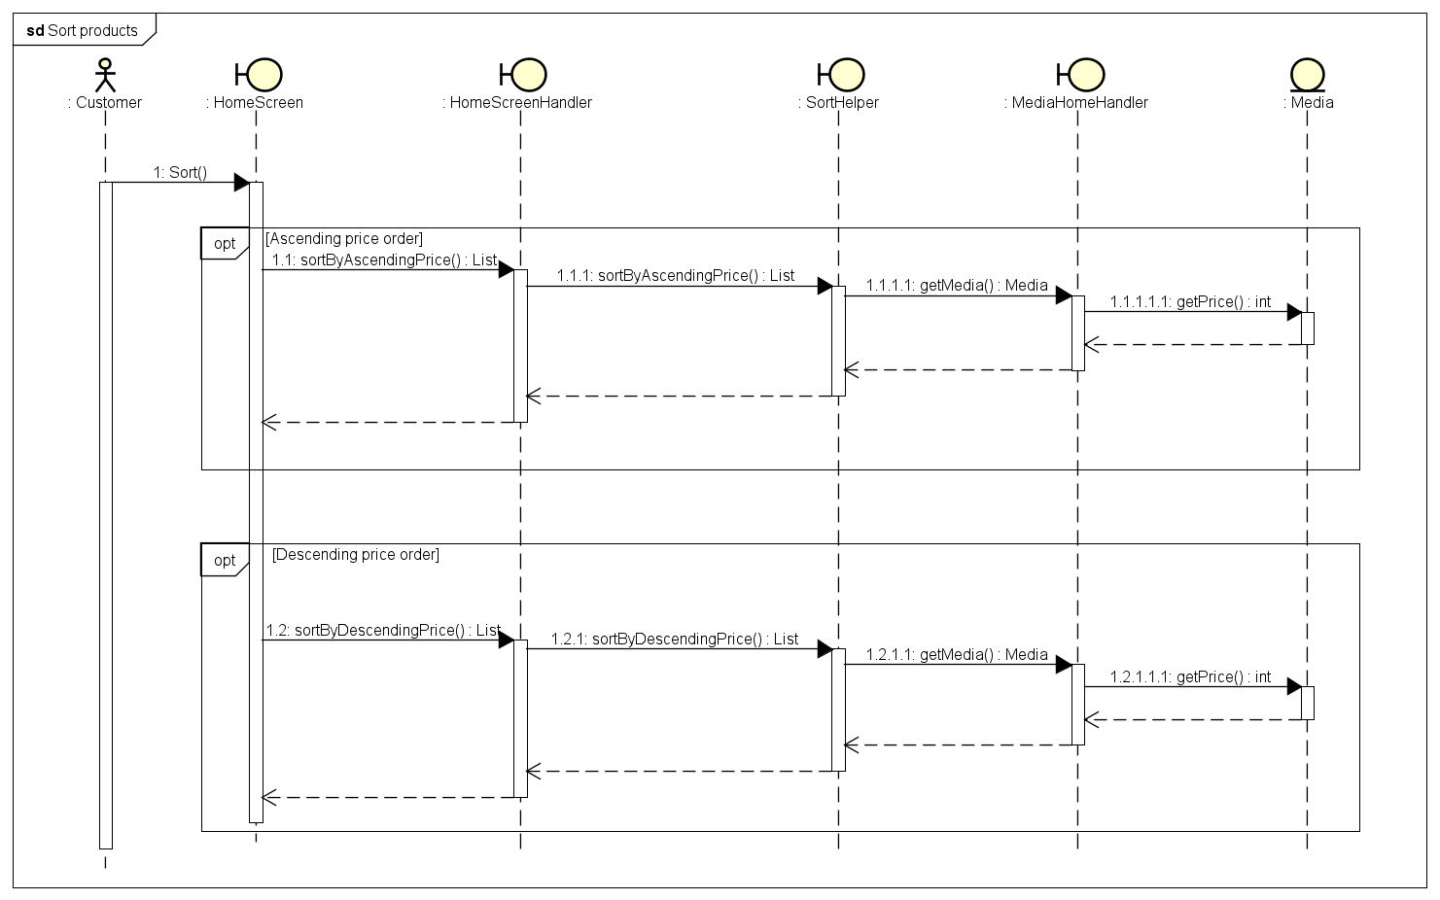

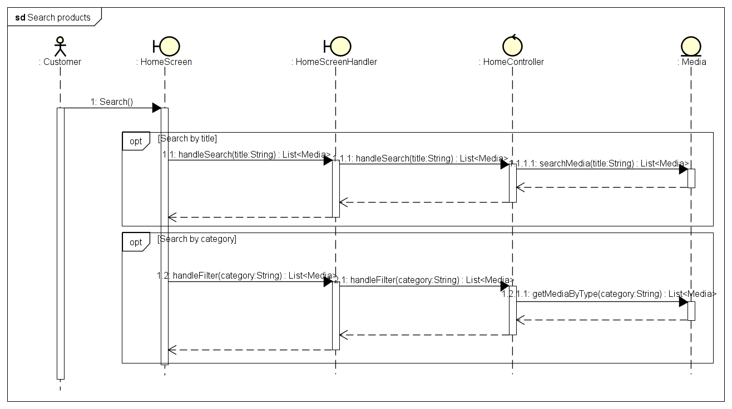

**Class diagram**

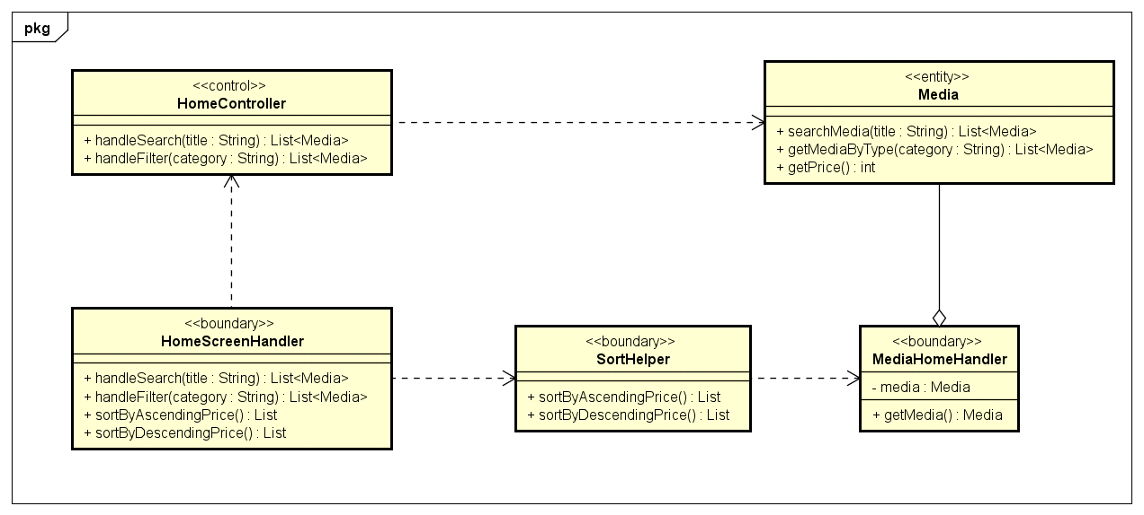

* 1. **Use case analysis for “View product detail”**

**Sequence diagram**

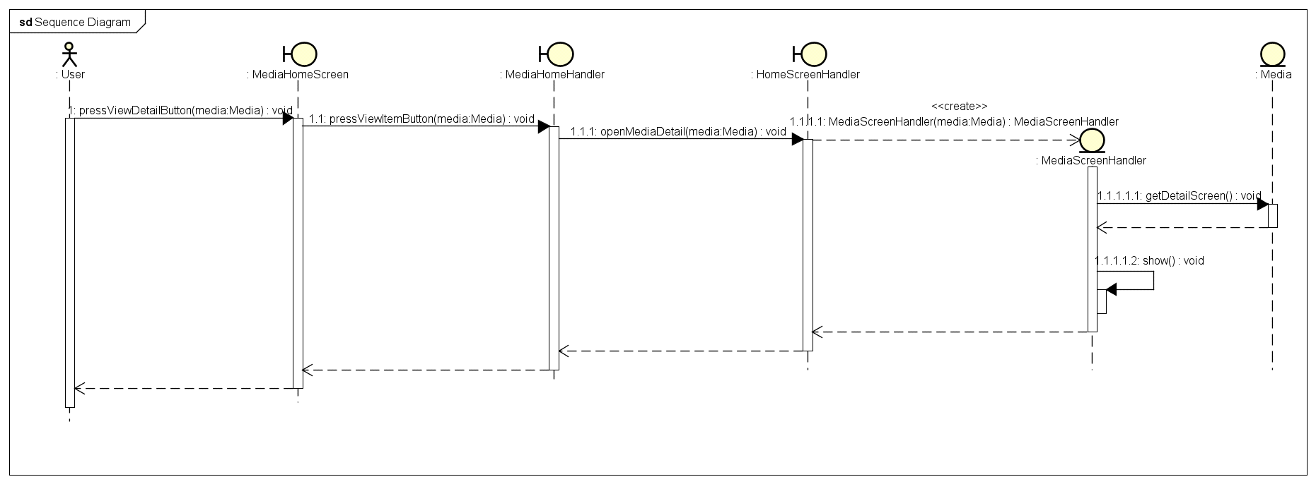

**Class diagram**

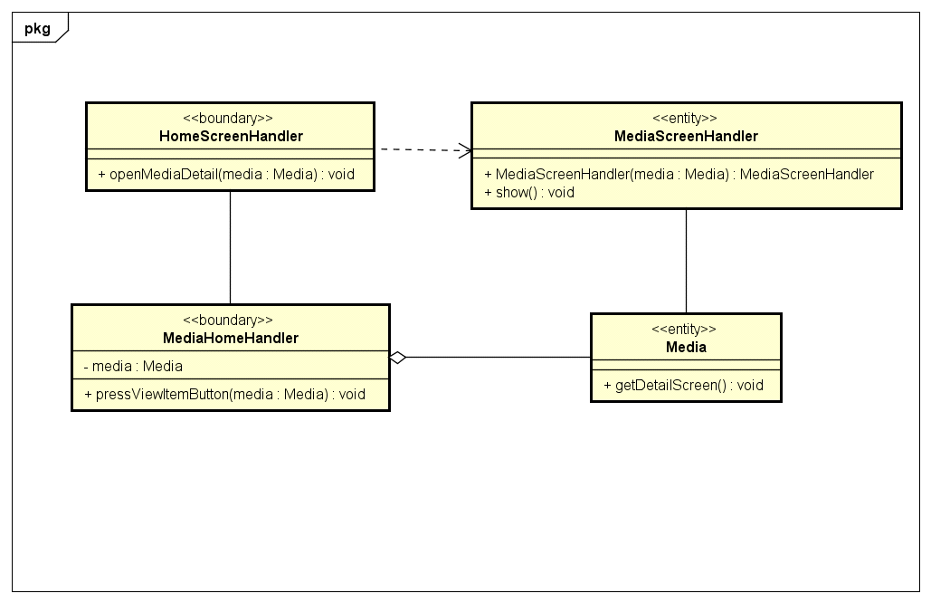

* 1. **Use case analysis for “Manage Cart”**

**Sequence diagram**

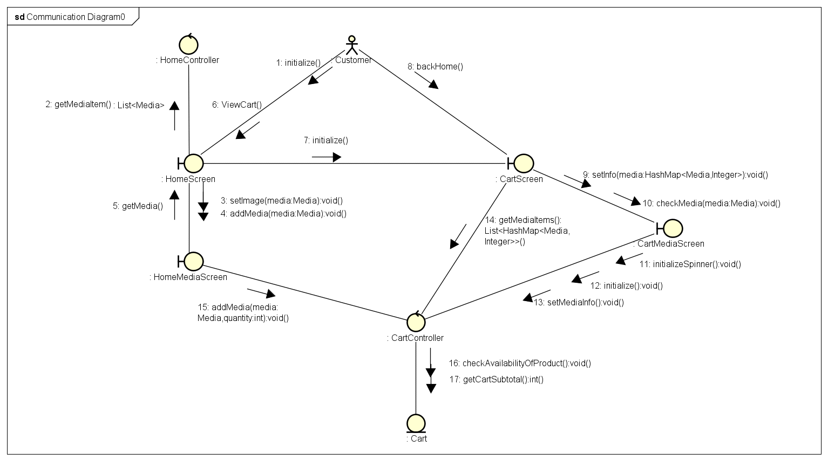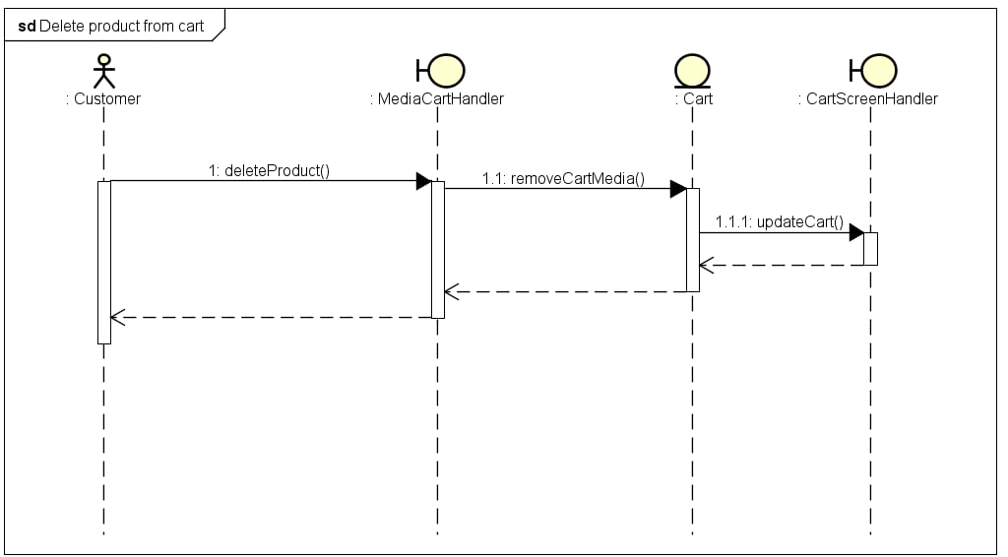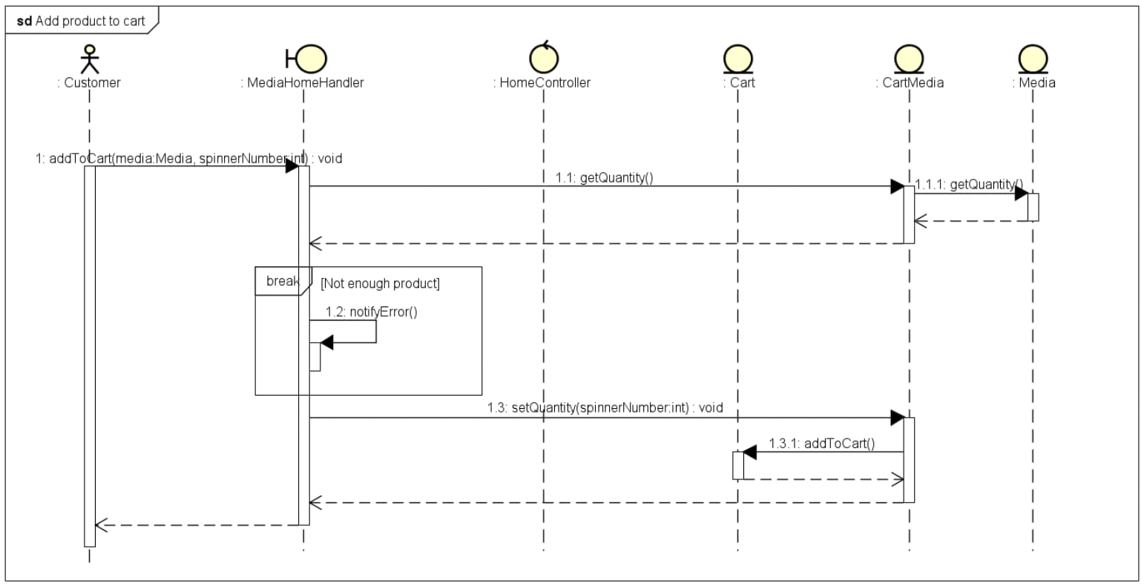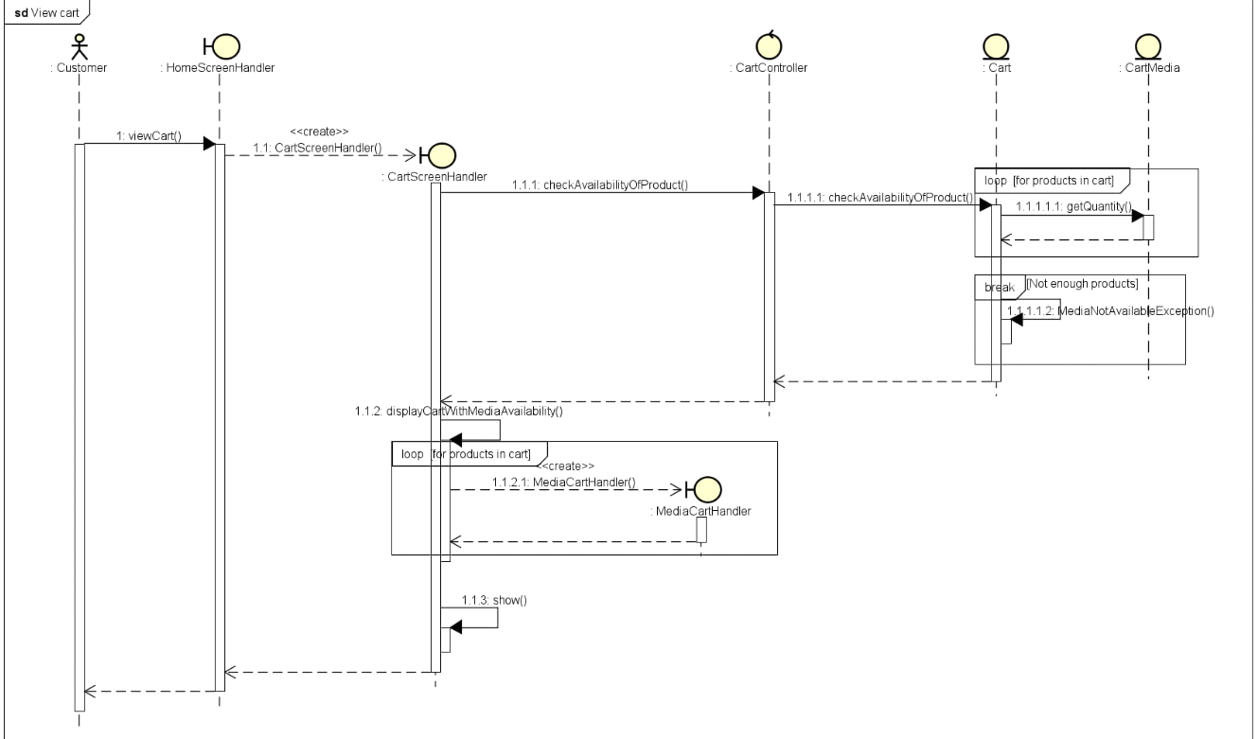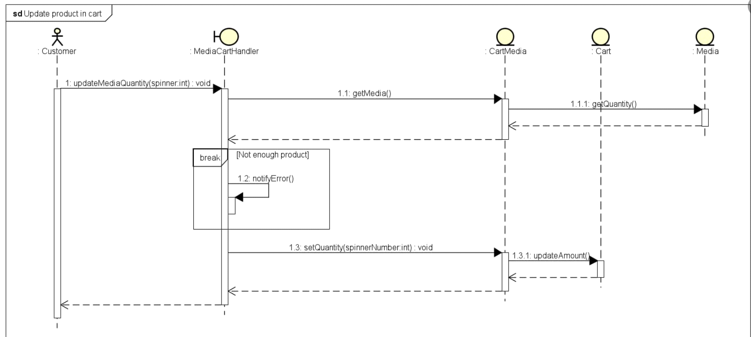

**Class diagram**

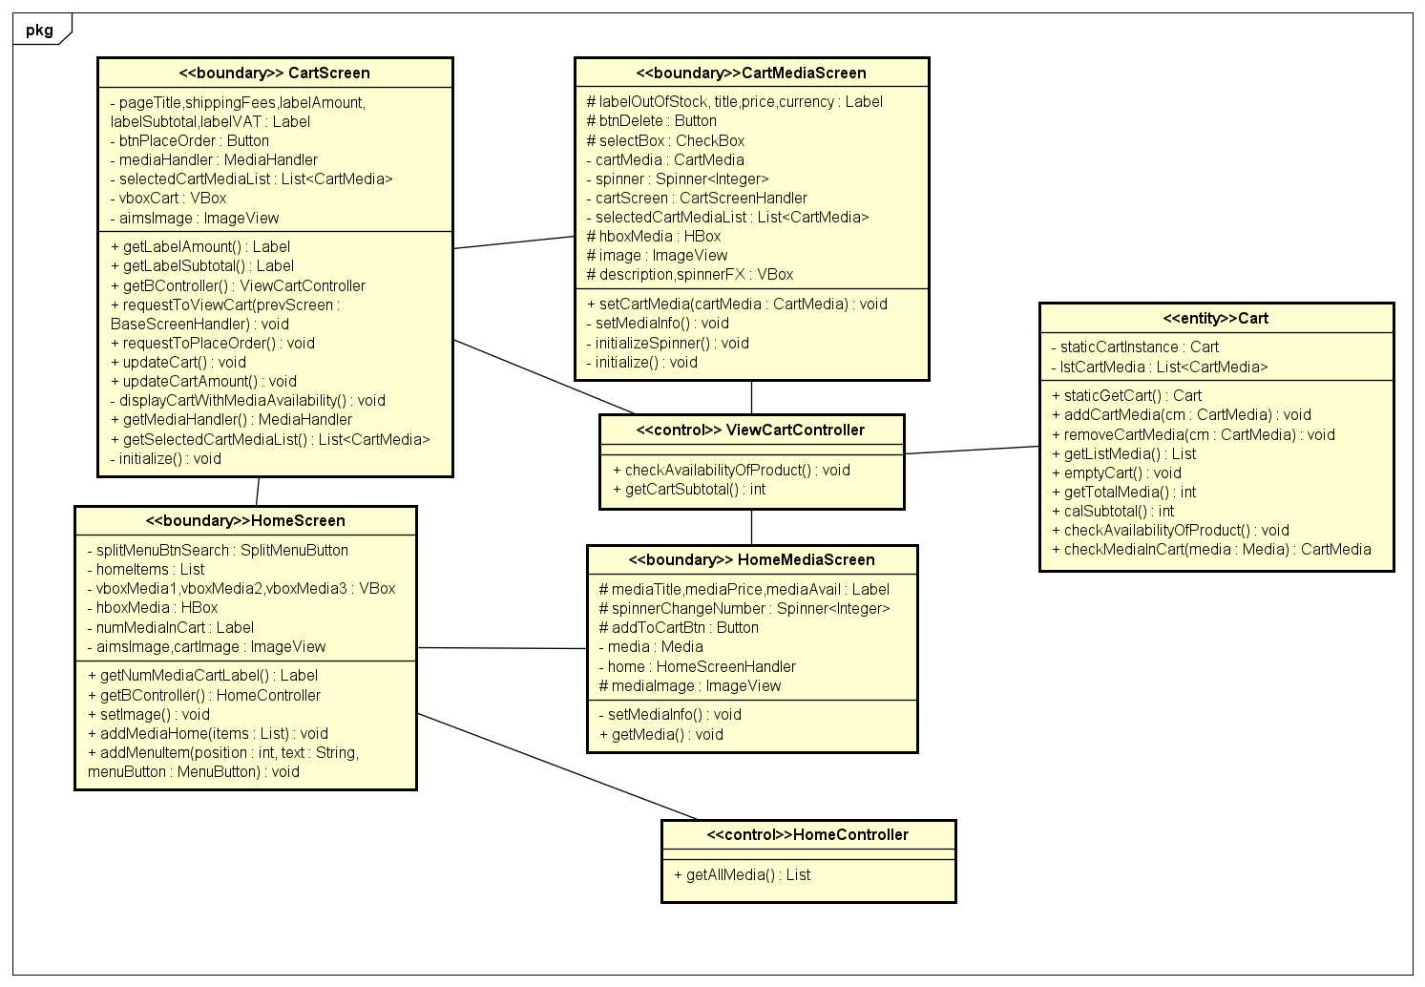

* 1. **Use case analysis for “Place Order”**

**Sequence Diagram:**

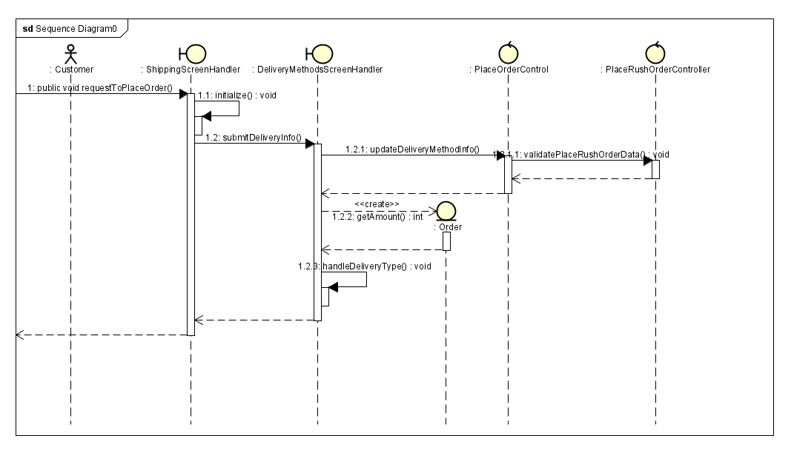

**Class diagram:**

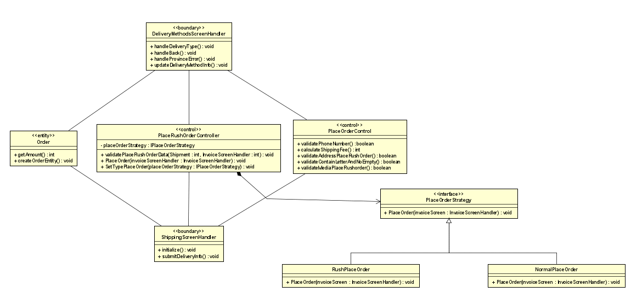

* 1. **Use case analysis for "Place Rush Order”**

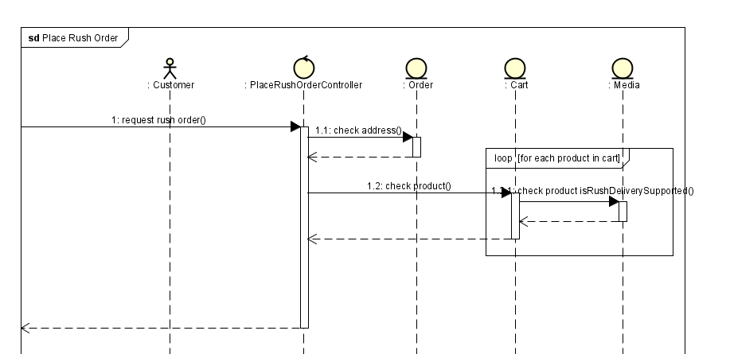

* 1. **Use case analysis for “Pay Order”**

**Class diagram:**

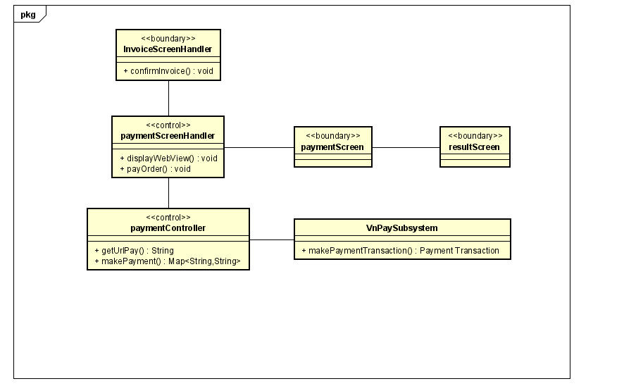

**Sequence Diagram:**

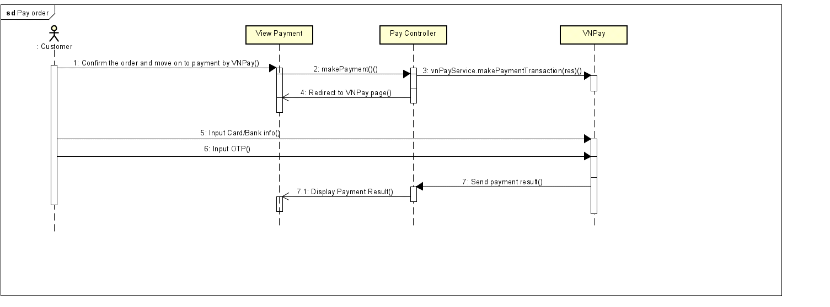

* 1. **Use case analysis for "View list of products”**

**Sequence Diagram:**

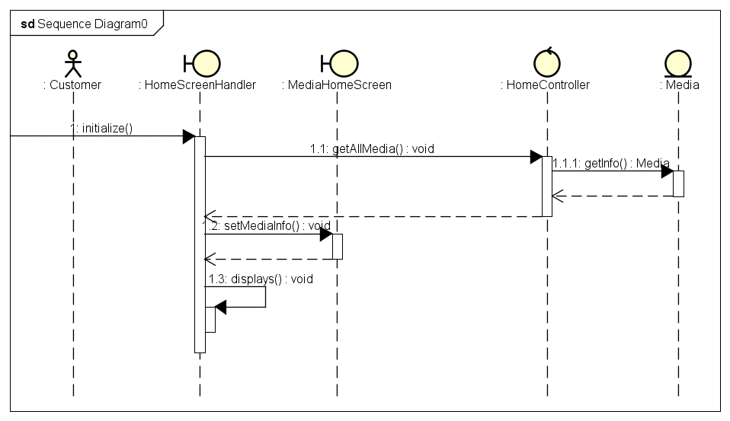

**Class Diagram:**

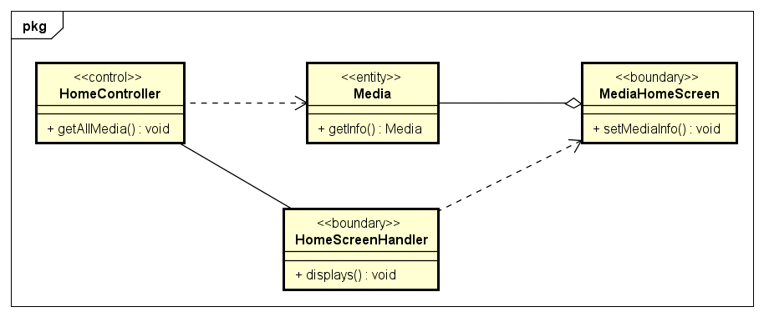

1. **Interface Design**
   1. **Splash screen**

|  |  |  |  |  |  |
| --- | --- | --- | --- | --- | --- |
| **Aims Software** | | **Date of creation** | **Approved by** | **Reviewed by** | **Persion in charge** |
| **Screen specification** | **Splash screen** | 17/06/2024 |  |  | Trinh Tien Dung |
|  | | **Control** | **Operation** | **Function** | |
| Main area | None | Loading | |

* 1. **Home Screen**

|  |  |  |  |  |  |
| --- | --- | --- | --- | --- | --- |
| **Aims Software** | | **Date of creation** | **Approved by** | **Reviewed by** | **Persion in charge** |
| Screen specification | Home screen | 17/06/2024 |  |  | Trinh Tien Dung |
|  | | Control | Operation | Function | |
| Page title | Click | Reload home screen | |
| Search bar | Type and Click | Category or title of search items and search | |
| Cart logo | Click | View items in the cart | |
| Scroll bar | Scroll | Scroll to see hidden items | |
| Login button | Click | Login as user | |
| Price button | Select and click | Sort items by price | |
| Pagination | Click | Go to other pages | |
| Main area | Click | Items detail info and add to cart | |

|  |  |  |  |  |
| --- | --- | --- | --- | --- |
| **Screen** | **Main screen** | | | |
| **Field name** | **Type** | **Limitation** | **Attribute** | **Remarks** |
| Media title | Text | 40 characters | Bold, black | Left-justified |
| Price | Digits | 10 digits | Bold, black | Left-justified  Dot for thousand separation |
| Avail | Digits | 5 digits | Bold, black | Left-justified |
| Item image | Image | 158x178 pixels | None | None |

* 1. **Product detail screen**

|  |  |  |  |  |  |
| --- | --- | --- | --- | --- | --- |
| **Aims Software** | | **Date of creation** | **Approved by** | **Reviewed by** | **Persion in charge** |
| **Screen specification** | **Product detail screen** | 17/06/2024 |  |  | Trinh Tien Dung |
|  | | **Control** | **Operation** | **Function** | |
| Area for display items in the cart | Initial | Displays detail information base on category | |
| Back button | Click | Go to back to home screen | |

|  |  |  |  |  |
| --- | --- | --- | --- | --- |
| **Screen** | **Main screen** | | | |
| **Field name** | **Type** | **Limitation** | **Attribute** | **Remarks** |
| Media title | Text | 40 characters | Black | None |
| Item image | Image | 400 width pixels | None | None |
| Media detail information | Text | 1000 characters | Black | None |

* 1. **Cart**

|  |  |  |  |  |  |
| --- | --- | --- | --- | --- | --- |
| **Aims Software** | | **Date of creation** | **Approved by** | **Reviewed by** | **Persion in charge** |
| **Screen specification** | **View cart screen** | 17/06/2024 |  |  | Trinh Tien Dung |
|  | | **Control** | **Operation** | **Function** | |
| Area for displaying the subtotal | Initial | Display the subtotal | |
| Area for display items in the cart | Initial | ***Display the product with corresponding information*** | |
| Place order button | Click | Display the Delivery form | |
| Edit number button | Click/Input | Change number of selected products | |
|  | | Remove button | Click | Remove product from cart | |
|  | | Back button | Click | Back to home screen | |

|  |  |  |  |  |
| --- | --- | --- | --- | --- |
| **Screen** | **Cart screen** | | | |
| **Field name** | **Type** | **Limitation** | **Attribute** | **Remarks** |
| Media title | Text | 40 characters | Bold, black | Left-justified |
| Quantity | Digits | 5 digits | None | Left-justified |
| Price | Digits | 10 digits | Green | Left-justified  Dot for thousand separation |
| Subtotal |
| Currency | Text | 3 characters | All caps | None |
| Item thumbnail | Image | 95x103 pixels | None | None |

* 1. **Shipping information Screen**

|  |  |  |  |  |  |  |  |  |  |  |  |
| --- | --- | --- | --- | --- | --- | --- | --- | --- | --- | --- | --- |
| **Aims Software** | | | | | **Date of creation** | | **Approved by** | | **Reviewed by** | **Persion in charge** | |
| **Screen specification** | | | **Delivery Form** | | 17/06/2024 | |  | |  | Trinh Tien Dung | |
|  | | | | | **Control** | | **Operation** | | **Function** | | |
| Area for filling the name | | Input | | *Fill name of the customer* | | |
| *Area for filling phone* | | Input | | *Fill phone of the customer* | | |
| *Area for filling email* | | Input | | *Fill email of the customer* | | |
| province selecting dropdown | | Select | | Change province of customer | | |
| district selecting dropdown | | select | | change district of customer | | |
| ward selecting dropdown | | select | | change ward of customer | | |
| area for filling address | | input | | fill specific address of the customer | | |
| type selecting dropdown | | selecting | | select the shipping type: rush or normal | | |
| area for filling instruction | | input | | fill shipping instruction of the customer | | |
| submit button | | click | | save information and process to view invoice | | |
| back button | | click | | back to previous page | | |
| **Screen** | **Deliver screen** | | | | | | | | |
| **Field name** | **Type** | | **Limitation** | | **Attribute** | | **Remarks** | | |
| Province | Select from list | | None | | None | | None | | |
| Delivery type | Select from list | | rush or normal | | None | | None | | |
| District | select from list | | none | | none | | none | | |
| Ward | select from list | | none | | none | | none | | |

* 1. **Invoice Screen**

|  |  |  |  |  |  |
| --- | --- | --- | --- | --- | --- |
| **Aims Software** | | **Date of creation** | **Approved by** | **Reviewed by** | **Persion in charge** |
| **Screen specification** | **Invoice Screen** | 07/04/2024 |  |  | Trinh Tien Dung |
|  | | **Control** | **Operation** | **Function** | |
| Area for displaying the input address | Initial | Display the selected shipping address | |
| Area for displaying the customer’s phone number | Initial | Display the customer’s phone number | |
| Area for displaying the customer’s name | Initial | Display the customer’s name | |
| Area for displaying the customer’s instruction | Initial | Display the customer’s instruction | |
| Area for displaying the shipping fee | Initial | Display the customer’s shipping fee | |
| Area for displaying the product list with specified info for each product | Initial | Display the customer’s product list | |
| Confirm button | Click | Save information and process to invoice screen | |
| Area for displaying the selected province | initial | display the customer’s province | |
| Area for displaying the customer’s district | initial | display the customer’s district | |
| Area for displaying the customer’s ward | initial | display the customer’s ward | |
| Area for displaying the customer’s delivery time | initial | display selected delivery time if the shipping type is rush order | |
| Area for displaying the customer’s email | initial | display the customer’s email | |

|  |  |  |  |  |
| --- | --- | --- | --- | --- |
| **Screen** | **Normal order invoice & Rush order invoice screen** | | | |
| **Field name** | **Type** | **Limitation** | **Attribute** | **Remarks** |
| Media title | Text | 40 characters | Bold, black | Left-justified |
| Subtotal | Digits | 10 digits | None | Left-justified  Dot for thousand separation |
| Shipping fee |
| Price | Green |
| Items |
| Total |
| Item thumbnail | Image | 163x128 pixels | None | None |
| Customer name | Text | 50 characters | Italic | None |
| Province |  | 80 characters |  |  |
| Address |  | None |  |  |
| Shipping instruction |  | 100 characters |  |  |
| Customer phone | Digits | 10 digits | Italic | None |
| District |  | 100 characters |  | None |
| Ward |  | 100 character |  | None |
| Email |  | 100 character |  | None |

* 1. **Payment Screen**

|  |  |  |  |  |  |
| --- | --- | --- | --- | --- | --- |
| **Aims Software** | | **Date of creation** | **Approved by** | **Reviewed by** | **Persion in charge** |
| **Screen specification** | **Payment Screen** | 17/06/2024 |  |  | Trinh Tien Dung |
|  | | **Control** | **Operation** | **Function** | |
| ***Area for redirect to VNPay*** | ***Initial*** | ***Pay order through VNPay*** | |

* 1. **Payment Result**

|  |  |  |  |  |  |
| --- | --- | --- | --- | --- | --- |
| **Aims Software** | | **Date of creation** | **Approved by** | **Reviewed by** | **Persion in charge** |
| **Screen specification** | **Result Screen** | 17/06/2024 |  |  | Trinh Tien Dung |
|  | | **Control** | **Operation** | **Function** | |
| ***Area for displaying successful order*** | ***Initial*** | ***Display successful order*** | |
| ***Area for displaying message*** | ***Initial*** | ***Displays message*** | |
| ***Button*** | ***Click*** | ***Back to home screen*** | |

* 1. **Popup Screen**

|  |  |  |  |  |  |
| --- | --- | --- | --- | --- | --- |
| **Aims Software** | | **Date of creation** | **Approved by** | **Reviewed by** | **Persion in charge** |
| **Screen specification** | **Popup Screen** | 17/06/2024 |  |  | Trinh Tien Dung |
|  | | **Control** | **Operation** | **Function** | |
| ***Area for displaying icon*** | ***Initial*** | ***Display icon*** | |
| ***Area for displaying message*** | ***Initial*** | ***Displays message*** | |
| ***Button*** | ***Click*** | ***Close popup window*** | |

* 1. **Login Screen**

|  |  |  |  |  |  |
| --- | --- | --- | --- | --- | --- |
| **Aims Software** | | **Date of creation** | **Approved by** | **Reviewed by** | **Persion in charge** |
| **Screen specification** | **Login Screen** | 17/06/2024 |  |  | Trinh Tien Dung |
|  | | **Control** | **Operation** | **Function** | |
| ***Logo*** | Click | ***Go to home screen*** | |
| ***Login button*** | ***Click*** | ***Login with username and password*** | |
| ***Area for inputting username*** | ***Input*** | ***Fill username*** | |
| ***Area for inputting password*** | ***Input*** | ***Fill password*** | |

* 1. **Product Manager**

|  |  |  |  |  |  |
| --- | --- | --- | --- | --- | --- |
| **Aims Software** | | **Date of creation** | **Approved by** | **Reviewed by** | **Persion in charge** |
| **Screen specification** | **Product Manager Screen** | 17/06/2024 |  |  | Trinh Tien Dung |
|  | | **Control** | **Operation** | **Function** | |
| ***Change password button*** | Click | ***Change password*** | |
| ***Logout button*** | ***Click*** | ***Logout*** | |
| ***Create button*** | ***Click*** | ***Create new media*** | |
| ***Update button*** | ***Click*** | ***Update selected media*** | |
| ***Delete button*** | ***Click*** | ***Delete selected media*** | |
| ***Area for displaying media information*** | ***Initial*** | ***Display all media by category*** | |

* 1. **Media Manager**

|  |  |  |  |  |  |
| --- | --- | --- | --- | --- | --- |
| **Aims Software** | | **Date of creation** | **Approved by** | **Reviewed by** | **Persion in charge** |
| **Screen specification** | **View Product Screen** | 17/06/2024 |  |  | Trinh Tien Dung |
|  | | **Control** | **Operation** | **Function** | |
| ***Change password button*** | Click | ***Change password*** | |
| ***Logout button*** | ***Click*** | ***Logout*** | |
| ***Area for displaying media information*** | ***Initial*** | ***Display all media by category*** | |

* 1. **User Manager**

|  |  |  |  |  |  |
| --- | --- | --- | --- | --- | --- |
| **Aims Software** | | **Date of creation** | **Approved by** | **Reviewed by** | **Persion in charge** |
| **Screen specification** | **User Manager Screen** | 17/06/2024 |  |  | Trinh Tien Dung |
|  | | **Control** | **Operation** | **Function** | |
| ***Change password button*** | Click | ***Change password*** | |
| ***Logout button*** | ***Click*** | ***Logout*** | |
| ***Create user button*** | Click | ***Create new user*** | |
| ***Update user button*** | Click | ***Update selected user*** | |
| ***Delete user button*** | Click | ***Delete selected user*** | |
| ***Ban/Unban user button*** | Click | ***Ban/Unbanselected user*** | |
| ***Area for displaying users*** | ***Initial*** | ***Display all users information*** | |

1. **Analysis Class Diagram**
   1. **General Class Diagram**

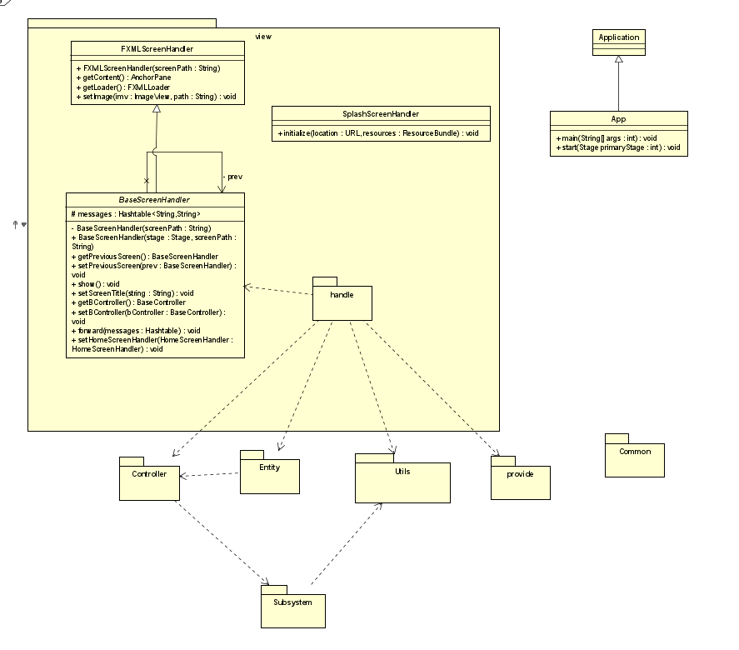

* 1. **Class Diagram for package view**

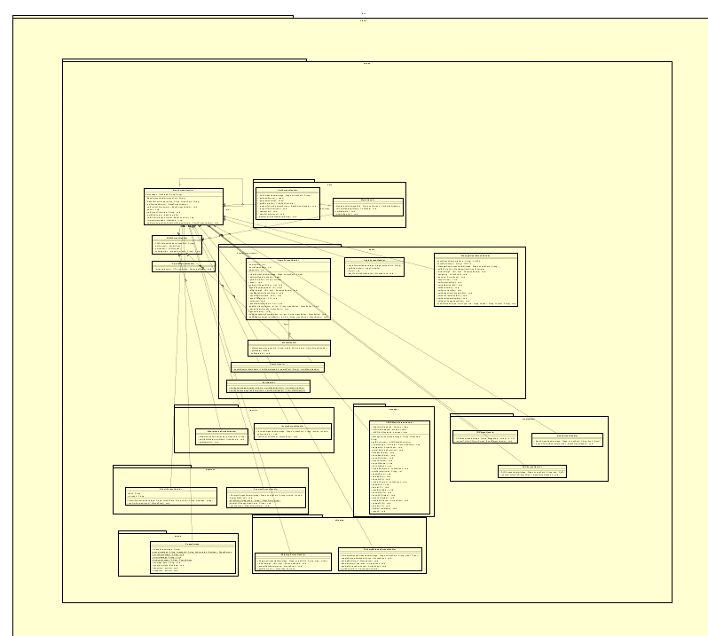

* 1. **Class Diagram for Package Common**

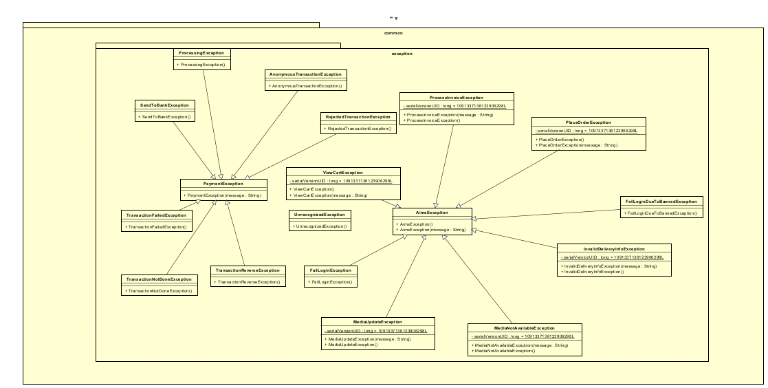

* 1. **Class Diagram for Package Entity**

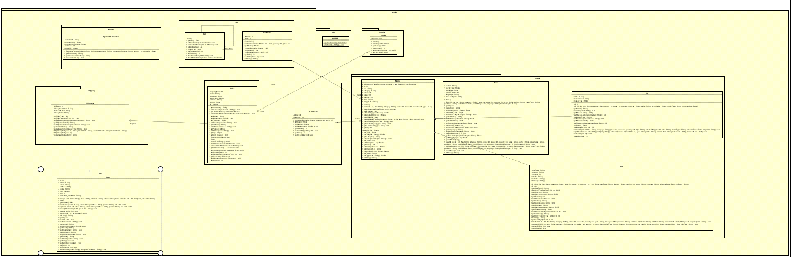

* 1. **Class Diagram for Package Subsystem**

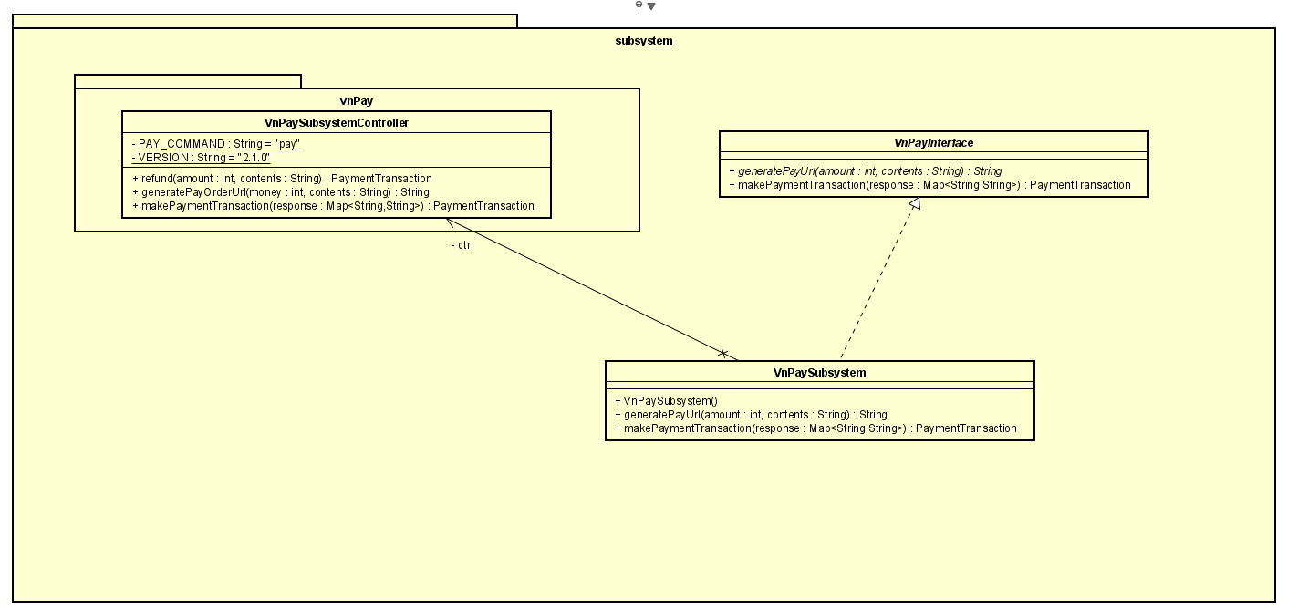

* 1. **Class diagram for Package Utils**

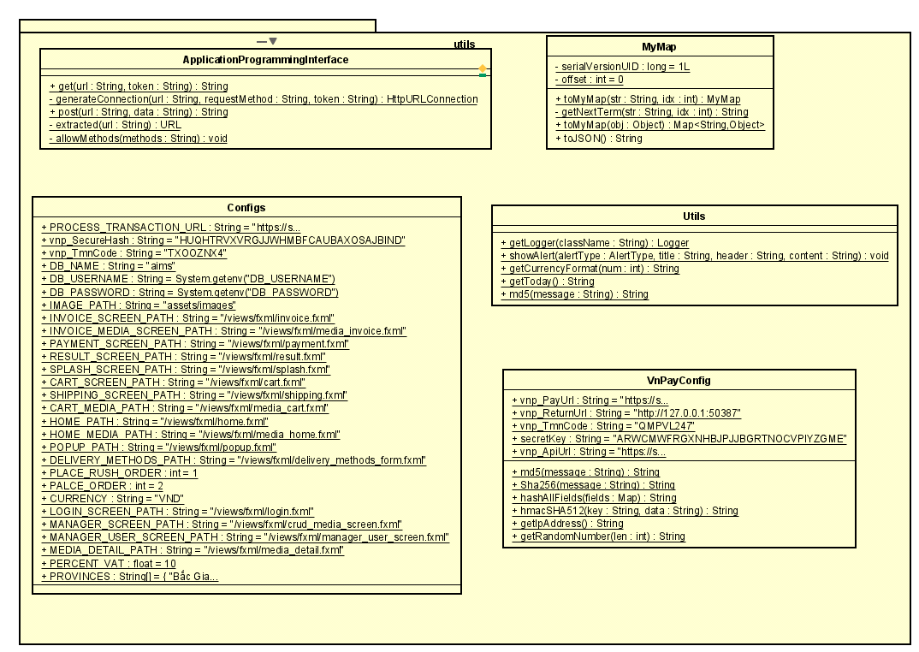

1. **Data Modeling**
   1. **Database Schema Diagram**

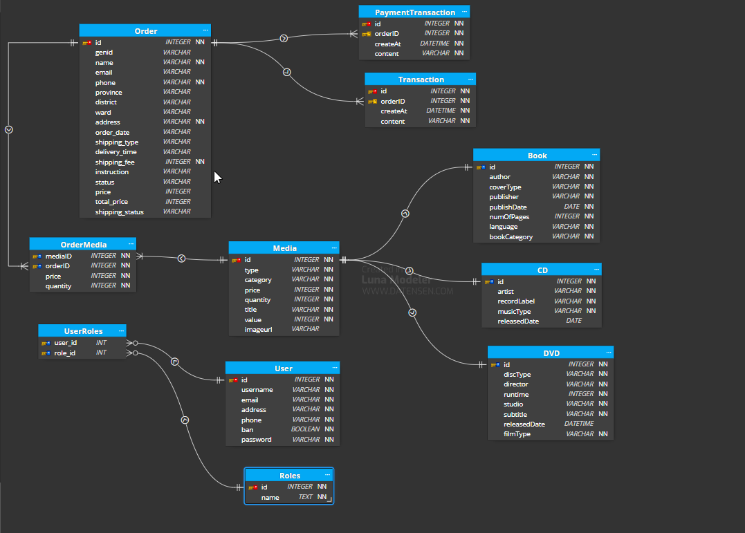

* 1. **Conceptual Data Model**

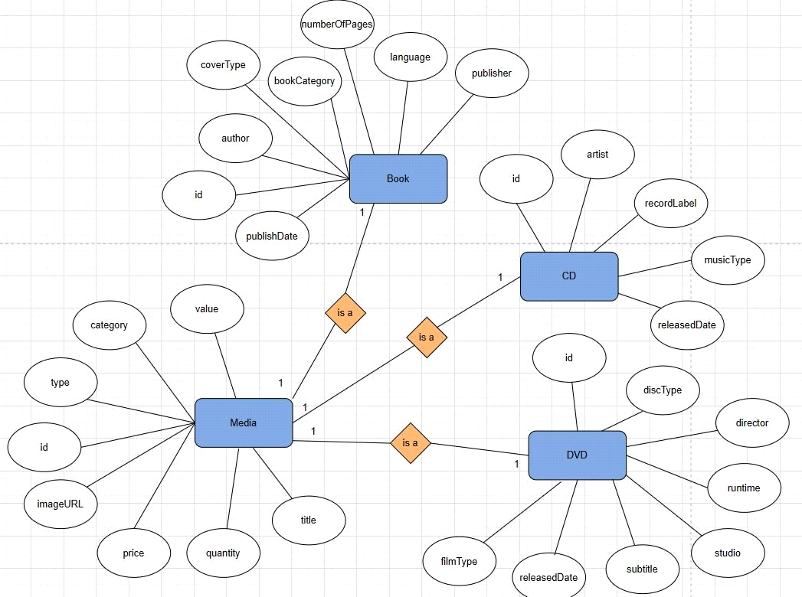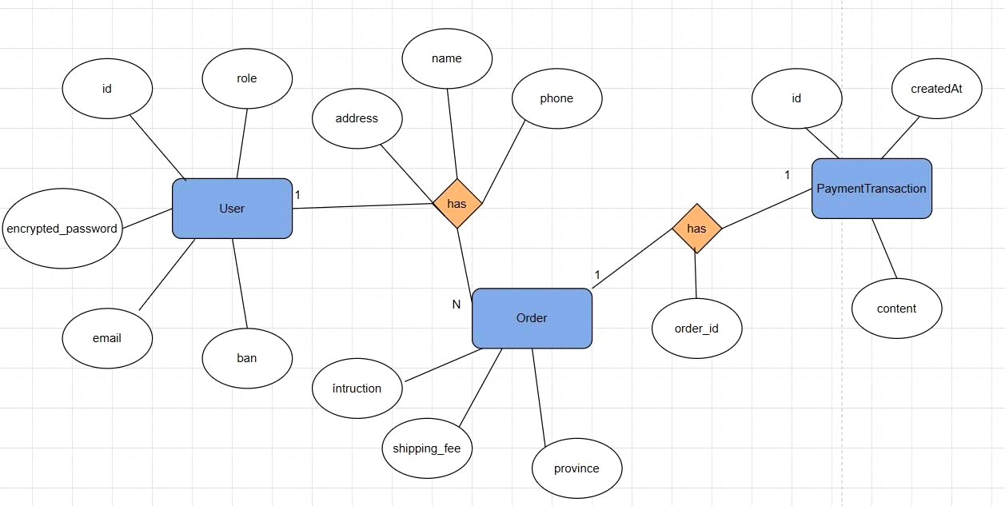

* 1. **Physical Data Model**

**Media**

|  |  |  |  |  |  |  |
| --- | --- | --- | --- | --- | --- | --- |
| STT | PK | FK | Trường | Kiểu dữ liệu | Bắt buộc | Mô tả |
| 1 | * |  | id | Integer | Có | ID, auto increment |
| 2 |  |  | type | Varchar(45) | Có | Loại sản phẩm |
| 3 |  |  | category | Varchar(45) | Có | Loại nội dung sản phẩm |
| 4 |  |  | price | Integer | Có | Giá sản phẩm |
| 5 |  |  | quantity | Integer | Có | Số lượng sản phẩm |
| 6 |  |  | title | Varchar(45) | Có | Tên sản phẩm |
| 7 |  |  | value | Integer | Có |  |
| 8 |  |  | imageURL | Varchar(45) | Có | Đường dẫn hình ảnh sản phẩm |

**Book**

|  |  |  |  |  |  |  |
| --- | --- | --- | --- | --- | --- | --- |
| STT | PK | FK | Trường | Kiểu dữ liệu | Bắt buộc | Mô tả |
| 1 | * |  | id | Integer | Có | ID, auto increment |
| 2 |  |  | author | Varchar(45) | Có | Tên tác giả |
| 3 |  |  | coverType | Varchar(45) | Có | Kiểu bìa sách |
| 4 |  |  | publisher | Varchar(45) | Có | Tên nhà xuất bản |
| 5 |  |  | publishDate | Date | Có | Ngày xuất bản |
| 6 |  |  | numberOfPages | Integer | Có | Số trang |
| 7 |  |  | languge | Varchar(45) | Có | Ngôn ngữ |
| 8 |  |  | bookCategory | Varchar(45) | Có | Thể loại nội dung |

**CD**

|  |  |  |  |  |  |  |
| --- | --- | --- | --- | --- | --- | --- |
| STT | PK | FK | Trường | Kiểu dữ liệu | Bắt buộc | Mô tả |
| 1 | * |  | id | Integer | Có | ID, auto increment |
| 2 |  |  | artist | Varchar(45) | Có | Tên nghệ sĩ |
| 3 |  |  | recordLabel | Varchar(45) | Có | Tên hãng sản xuất |
| 4 |  |  | musicType | Varchar(45) | Có | Thể loại nhạc |
| 5 |  |  | releasedDate | Date | Có | Ngày phát hành |

**DVD**

|  |  |  |  |  |  |  |
| --- | --- | --- | --- | --- | --- | --- |
| STT | PK | FK | Trường | Kiểu dữ liệu | Bắt buộc | Mô tả |
| 1 | * |  | id | Integer | Có | ID, auto increment |
| 2 |  |  | discType | Varchar(45) | Có | Kiểu đĩa |
| 3 |  |  | director | Varchar(45) | Có | Đạo diễn |
| 4 |  |  | runtime | Integer | Có | Thời lượng |
| 5 |  |  | studio | Varchar(45) | Có | Hãng sản xuất |
| 6 |  |  | subtitle | Varchar(45) | Có | Phụ đề |
| 7 |  |  | releasedDate | Date | Có | Ngày phát hành |
| 8 |  |  | filmType | Varchar(45) | Có | Thể loại nội dung |

**PaymentTransaction**

|  |  |  |  |  |  |  |
| --- | --- | --- | --- | --- | --- | --- |
| STT | PK | FK | Trường | Kiểu dữ liệu | Bắt buộc | Mô tả |
| 1 | * |  | id | Integer | Có | ID, auto increment |
| 2 |  | * | orderID | Integer | Có | ID đơn hàng |
| 3 |  |  | createAt | DateTime | Có | Thời gian giao dịch |
| 4 |  |  | content | Varchar(45) | Có | Nội dung |

**Order**

|  |  |  |  |  |  |  |
| --- | --- | --- | --- | --- | --- | --- |
| STT | PK | FK | Trường | Kiểu dữ liệu | Bắt buộc | Mô tả |
| 1 | * |  | id | Integer | Có | ID, auto increment |
| 2 |  |  | name | Varchar(45) | Có | Tên người đặt |
| 3 |  |  | address | Varchar(45) | Có | Địa chỉ nhận hàng |
| 4 |  |  | phone | Varchar(45) | Có | Số điện thoại người đặt |
| 5 |  |  | shipping_fee | Integer | Có | Phí vận chuyển |
| 6 |  |  | instruction | Varchar(255) | Có | Yêu cầu |
| 7 |  |  | province | Varchar(255) | Có | Tỉnh thành |
| 8 |  |  | district | Varchar(255) | Có | quận/huyện |
| 9 |  |  | ward | Varchar(255) | Có | xã/phường |
| 10 |  |  | email | Varchar(255) | Có | email |
| 11 |  |  | shipping_type | Varchar(255) | Có | phương thức vận chuyển: rush or normal |
| 12 |  |  | delivery_time | Varchar(20) | Không | thời gian giao hang mong muốn cho rush order |
| 13 |  |  | order_date | Varchar(20) | Có | tự động được set tại thời điểm user xác nhận hoá đơn |
| 14 |  |  | status | Varchar(20) | Có | trạng thái thanh toán đơn hang |
| 15 |  |  | shipping_status | Varchar(20) | Có | trạng thái giao hang |
| 16 |  |  | price | Integer | Có | giá tri đơn hang (không tính phí ship) |
| 17 |  |  | total_price | Integer | Có | tổng giá trị của đơn hàng |

**User**

|  |  |  |  |  |  |  |
| --- | --- | --- | --- | --- | --- | --- |
| STT | PK | FK | Trường | Kiểu dữ liệu | Bắt buộc | Mô tả |
| 1 | * |  | id | Integer | Có | ID, auto increment |
| 2 |  |  | username | Varchar(45) | Có | Tên đăng nhập |
| 3 |  |  | email | Varchar(45) |  | Email người dùng |
| 4 |  |  | address | Varchar(45) | Có | Địa chỉ người dùng |
| 5 |  |  | phone | Varchar(45) | Có | Số điện thoại người dùng |
| 6 |  |  | password | Varchar(45) | Có | Mật khẩu người dùng |
| 7 |  |  | role | Integer | Có | Quyền người dùng |
| 8 |  |  | ban | Boolean | Có | Tình trạng ban |

1. **Good Design**
   1. **Cohesion**

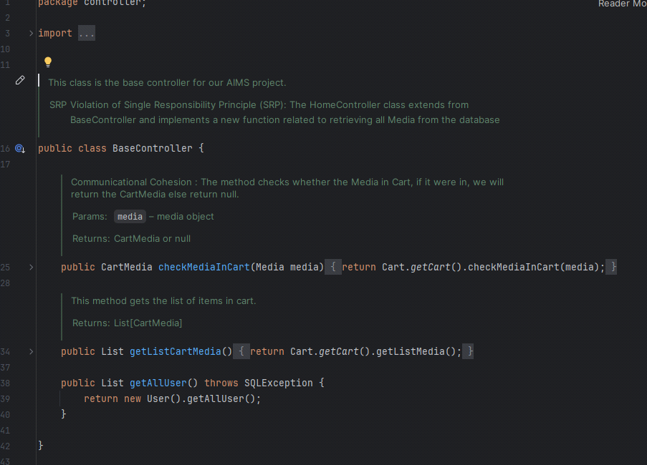

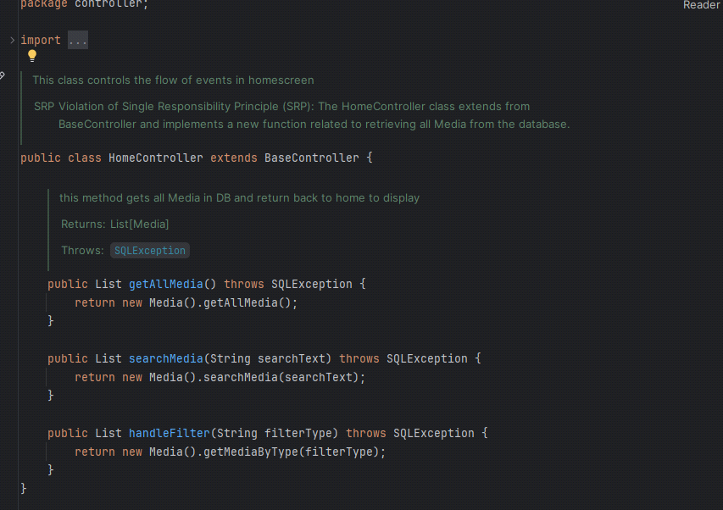

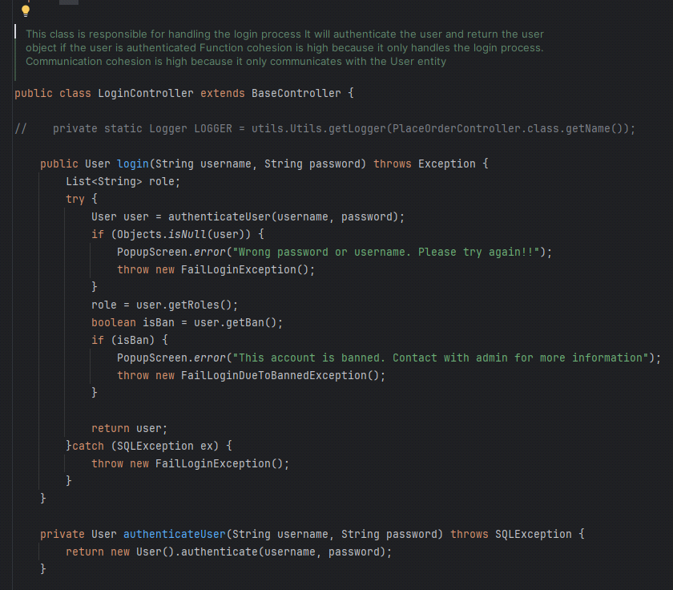

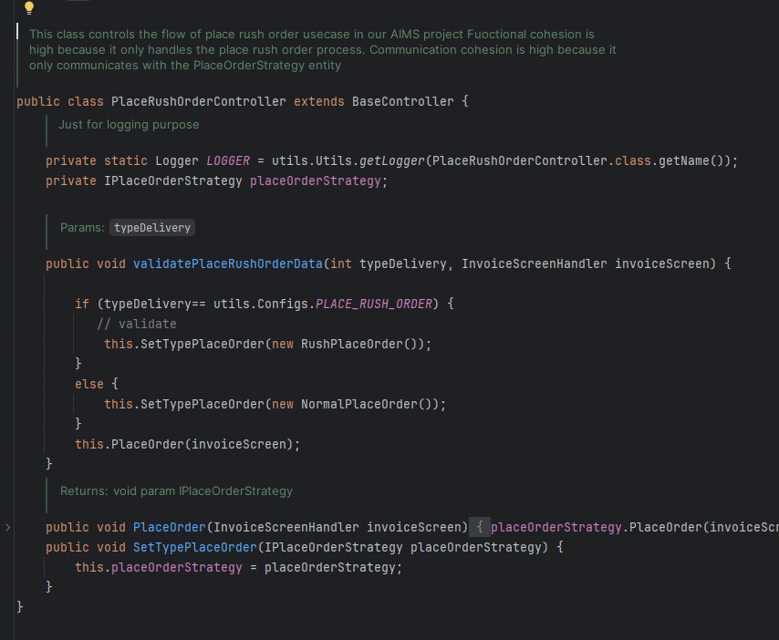

* 1. **Coupling**

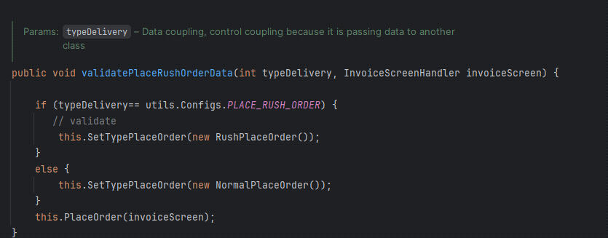

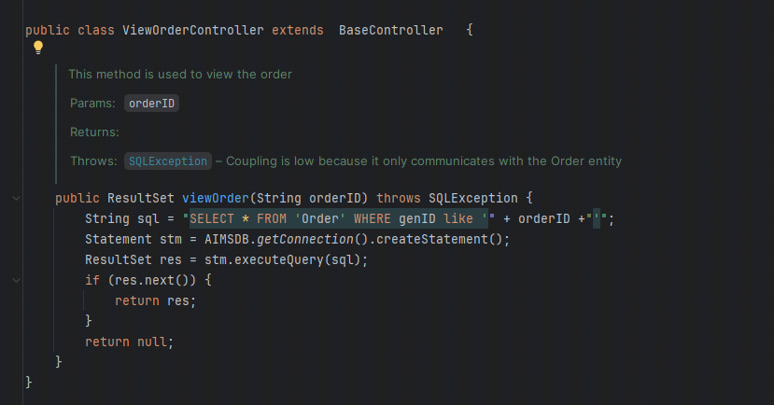

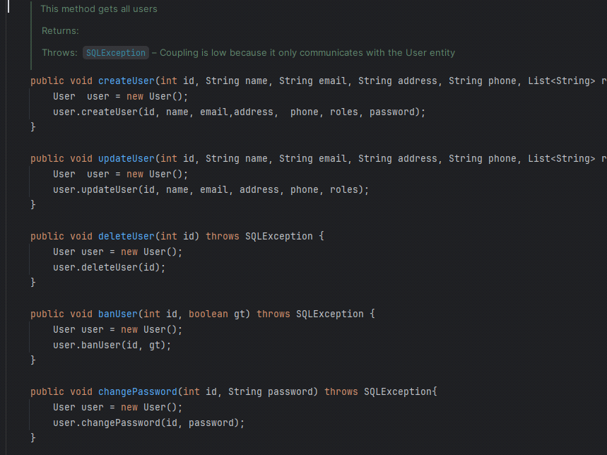

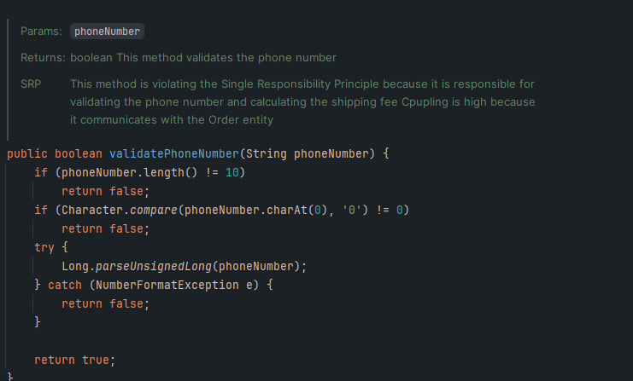

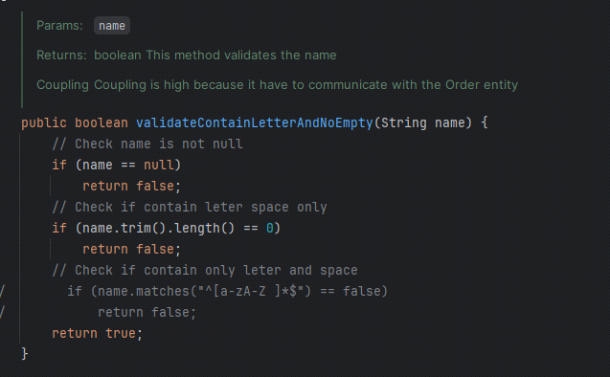

* 1. **SOLID**

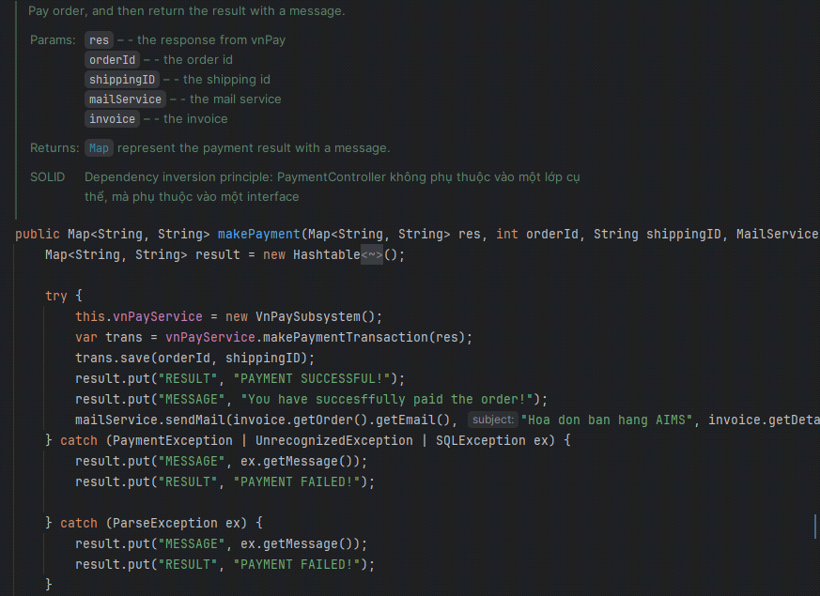

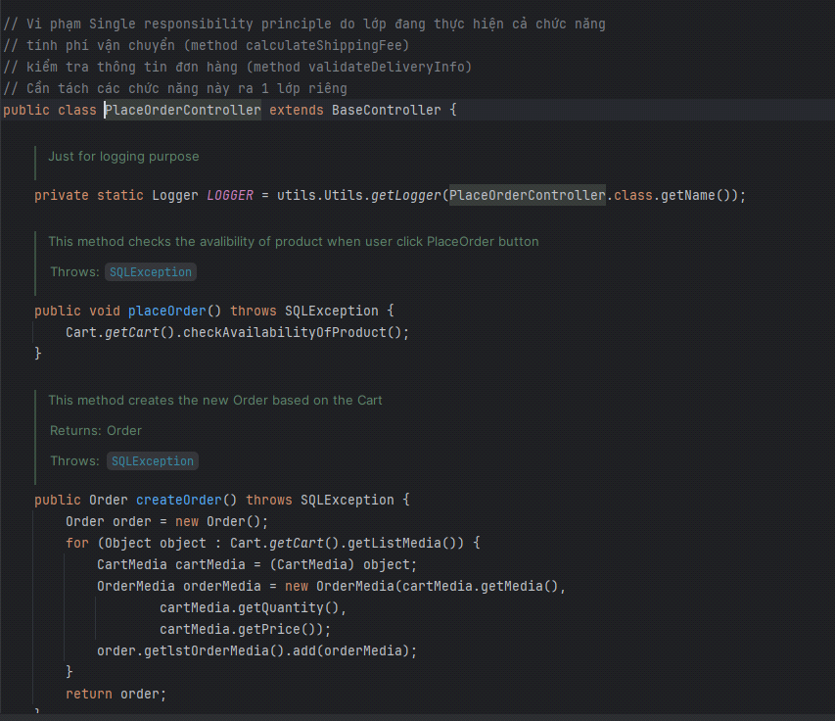

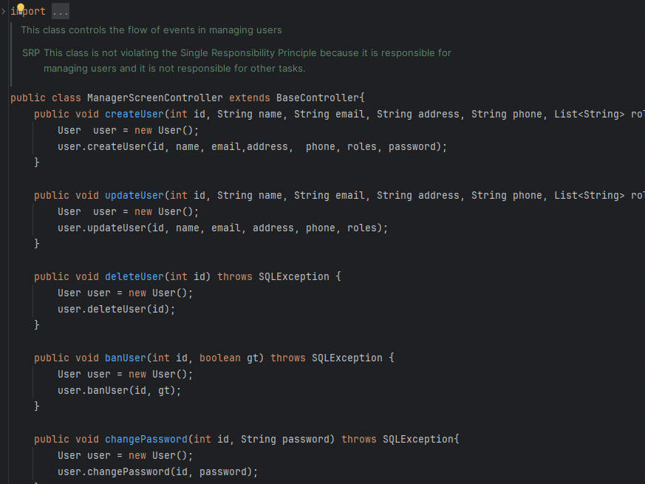

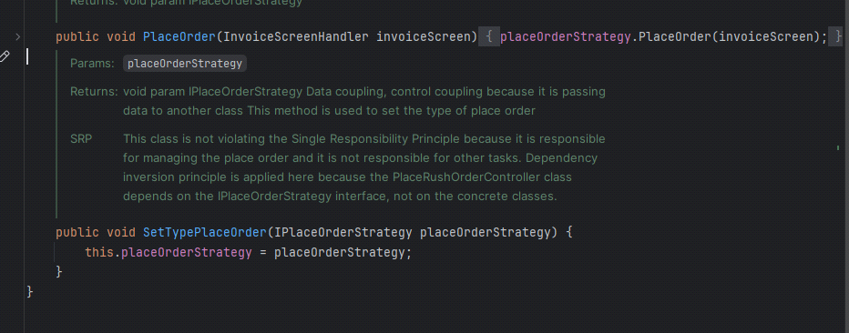

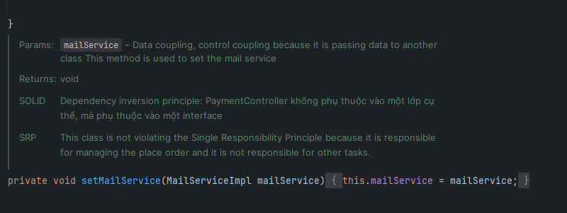

* 1. **Design Pattern**
     1. **Singleton**

- Singleton pattern is used in the Cart class. Cart has a private static field called cartInstance, which holds the single instance of the Cart class. The lstCartMedia field is a list that stores instances of CartMedia. It represents the items present in the shopping cart. The constructor of Cart is declared as private, preventing direct instantiation of the class from outside. The getCart method is a static public method that provides access to the single instance of the Cart class. It follows the Singleton pattern by ensuring that only one instance of Cart is created.

- By using the Singleton pattern, the Cart class ensures that there is only one instance of the class throughout the application, allowing centralized access to the shopping cart from different parts of the code. It is used in this scenarios to ensure there is only one cart per software session.

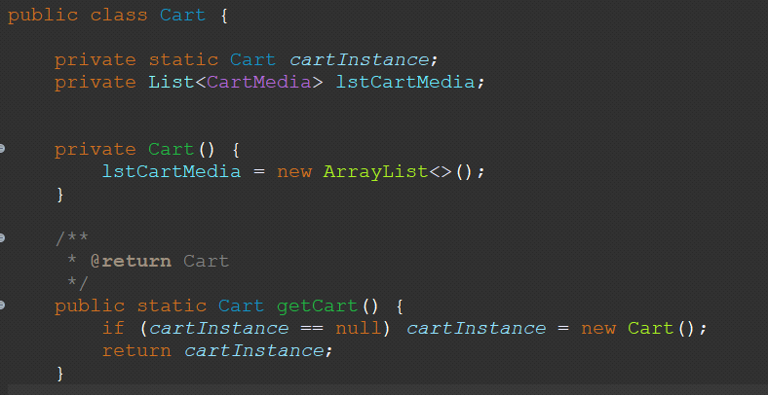

* + 1. **Strategy**

- Strategy Pattern is a behavioral design pattern that allows you to define a family of algorithms, encapsulate each one, and make them interchangeable. The strategy pattern lets the algorithm vary independently from the clients that use it.

- Using the Strategy Pattern for handling the delivery stage (calculating shipping fees, displaying the invoice), we can define different strategies for calculating shipping costs and displaying invoices.

- Using the Strategy Pattern allows you to flexibly choose and change the algorithms for calculating shipping fees and displaying invoices without modifying the Order class's code. This design pattern helps make the code more extensible, maintainable, and clear

